|  |
| --- |
| Name: J. A. Mujeeb |
| Student Reference Number: 10707284 |



|  |  |  |
| --- | --- | --- |
| Module Code: PUSL3111 | Module Name: API Software Development | |
| Coursework Title: API Coursework | | |
| Deadline Date: 11th May 2022 | | Member of staff responsible for coursework: Dr. Rasika Ranaweera |
| Programme: BSc (Hons) Plymouth Software Engineering | | |
| Please note that University Academic Regulations are available under Rules and Regulations on the University website [www.plymouth.ac.uk/studenthandbook](http://www.plymouth.ac.uk/studenthandbook). | | |
| Group work: please list all names of all participants formally associated with this work and state whether the work was undertaken alone or as part of a team. Please note you may be required to identify individual responsibility for component parts.  J. A. Mujeeb - 10707284  G.M.D.D. Ratnayake – 10707351  S.O. Perera – 10707315  N. S. De Alwis – 10707160  M. D. A. Medhavi – 10707278  P. P. L. Dilhani – 10709402  ***We confirm that we have read and understood the Plymouth University regulations relating to Assessment Offences and that we are aware of the possible penalties for any breach of these regulations. We confirm that this is the independent work of the group.***  Signed on behalf of the group: J. A. Mujeeb | | |
| Individual assignment: ***I confirm that I have read and understood the Plymouth University regulations relating to Assessment Offences and that I am aware of the possible penalties for any breach of these regulations. I confirm that this is my own independent work.***  Signed : | | |
| Use of translation software: failure to declare that translation software or a similar writing aid has been used will be treated as an assessment offence.  I *have used/not used translation software.  If used, please state name of software………………………………………………………………… | | |
| **Overall mark _____% Assessors Initials ______ Date_________** | | |

* *Please delete as appropriateSci/ps/d:/students/cwkfrontcover/2013/14

Table of Contents

2. Acknowledgement - 7

2.1 Abstract 7

2.2 Introduction 7

2.2.1 Quick Start Guide 7

3. Project Scope 9

3.1 Citizens 9

3.2 Bureau Officers (acts as an admin) 9

3.3 Foreign Companies Employers 9

4. System Architecture 9

4.1 Data Flow Diagram Level 0 9

4.2 Data Flow Diagram Level 1 10

4.3 Use Case Diagram 10

4.4 Class Diagram 11

4.5 Entity Diagram 11

4.6 Flow Chart 12

5. API Documentation 13

5.1 POST /citizens 13

5.2 PUT /citizens/:nid 13

5.3 GET /citizens/:nid 13

5.4 PUT /citizens/:nid 14

5.5 GET /citizens/find(:qualifications) 14

5.6 DELETE /citizens/:nid 14

5.7 GET /citizens/:nid/contacts 14

5.8 JSON Requests and Responses 14

5.9 XML requests and responses 14

6. Tools and technologies 14

6.1 PhpMyAdmin 14

6.2 Laravel 15

6.3 PHP 15

6.4 XML 15

6.5 Java 15

6.6 JavaScript Object Notation (JSON) 15

7. Sri Lanka Bureau of Foreign Employment (SLBFE) 16

7.1 Client Mobile Application Registration 16

7.2 User/Client Website Features 19

7.3 Admin Website Features 20

7.3.1 User Qualifications Profile 20

7.3.2 New Vacancy 20

7.3.3 Complaints 20

7.3.4 Seekers 20

7.3.5 Users 20

7.3.6 Logout 20

8. Code Screenshots 22

8.1 Screenshot of the Mobile Application Code 35

8.1.1 Vacancy Adapter 36

8.1.2 Dashboard 36

8.1.3 Login 37

8.1.4 Main Activity 37

8.1.5 Sign Up 38

8.1.6 Vacancy Record 38

8.1.7 Project Structure 39

8.2 Testing in POSTMAN 39

8.3 XML 44

9. Individual Contributions 47

9.1 N. S. D. Alwis (10707160) 47

9.2 G. M. D. D. Rathnayake (10707351) 48

9.3 S. O. Perera (10707315) 49

9.4 P. P. L. Dilhani (10709402) 50

9.5 J.A. Mujeeb (10707284) 51

9.6 M. D. A. Medhavi (10707278) 52

10. Team Contribution 53

11. References 54

Figure 1: Type "php artisan migrate" 8

Figure 2: Type "php artisan migrate" 8

Figure 3: Type "php artisan serve –port=8001" 8

Figure 4: database configuration 8

Figure 5: Database Table 9

Figure 6: Context Diagram 10

Figure 7: Data flow diagram - Level 1 10

Figure 8: Use case Diagram 11

Figure 9: Class Diagram 11

Figure 10: Entity Diagram 12

Figure 11: Flow chart 12

Figure 12: Login page in website 16

Figure 13: Mobile App Registration 16

Figure 14: Toast for confirmation 17

Figure 15: Mobile App Login page 17

Figure 16: Mobile app Vacancy scree 18

Figure 17: Citizen's profile updating page example 19

Figure 18: Complaints page 20

Figure 19: Job seekers 20

Figure 20: Admin side - create citizen profile 21

Figure 21: Replying complaints 21

Figure 22: View Job seeker page 21

Figure 23: New Vacancy 22

Figure 24: Manage Users 22

Figure 25: channels.php 22

Figure 26: api.php 23

Figure 27: console.php 23

Figure 28: web.php 23

Figure 29: AuthController.php (Part 1) 24

Figure 30: AuthController.php (Part 2) 24

Figure 31: AuthController.php (Part 3) 24

Figure 32: ComplaintsController.php 25

Figure 33: Controller.php 25

Figure 34: JobController.php 26

Figure 35: JobController.php (Part 2) 26

Figure 36: JobController.php (Part 3) 26

Figure 37: JobController.php (Part 3) 27

Figure 38: JobController.php (Part 4) 27

Figure 39: UserController.php 27

Figure 40: migrations folder 28

Figure 41: complaints.blade.php 28

Figure 42: complaints.blade.php (Part 2) 29

Figure 43: complaints.blade.php (Part 3) 29

Figure 44: complaints.blade.php (Part 4) 29

Figure 45: dashboard.blade.php 30

Figure 46: dashboard.blade.php (Part 2) 30

Figure 47: dashboard.blade.php (Part 3) 30

Figure 48: dashboard.blade.php (Part 4) 31

Figure 49: login.blade.php 31

Figure 50: login.blade.php (Part 2) 31

Figure 51: seekers.blade.php 32

Figure 52: seekers.blade.php (Part 2) 32

Figure 53: seekers.blade.php (Part 3) 32

Figure 54: users.blade.php 33

Figure 55: users.blade.php (Part 2) 33

Figure 56: users.blade.php (Part 3) 33

Figure 57: vacancy.blade.php 34

Figure 58: vacancy.blade.php (Part 2) 34

Figure 59: vacancy.blade.php (Part 3) 34

Figure 60: Middleware Folder 35

Figure 61: Routes Folder 35

Figure 62: VacancyAdapter.java 36

Figure 63: Dashboard.java 36

Figure 64: Login.java 37

Figure 65: MainActivity.java 37

Figure 66: Signup.java 38

Figure 67: VacancyRecord.java 38

Figure 68: Project Structure 39

Figure 69: Login 40

Figure 70: List Vacancy 41

Figure 71: Get Qualification 41

Figure 72: Get Complains 42

Figure 73: Get Users 42

Figure 74: Add Vacancy 43

Figure 75: Add Qualification 43

Figure 76: Add Complains 44

Figure 77: Reply Complains 44

Figure 78: Login XML Code 45

Figure 79: Add Qualifications XML Code 45

Figure 80: Add Complains XML Code 46

Figure 81: Reply Complaints XML Code 46

# Acknowledgement -

First and foremost, we’d like to express our sincere appreciation and gratitude towards Dr. Rasika Ranaweera, our module lecturer. It is with great humility that we humbly accept his valuable mentorship, guidance, and support.

In pursuit of the overall success of this project, a sufficient amount of guidance was demanded from many individuals. As a team, we’ve been exceedingly fortuitous to have had this from beginning to end.

In conclusion, we would not have been able to successfully complete the assignment without the hard work and assistance of all the team colleagues itself. We’ve all enjoyed working with each other.

## Abstract

This assignment comprises of a documented report on an API Web Application and Mobile Application, pertinent to the Sri Lanka Bureau of Foreign Employment (SLBFE).

Coursework Supervisor: Dr. Rasika Ranaweera

Group: Group No. 22

Deadline: 11th of May 2022

## Introduction

The Sri Lanka Bureau of Foreign Employment (SLBFE) is a government owned foreign employment agency that assists its citizens in the procurement of global employment opportunities.

It is evident that labour is a fundamental asset that would greatly contribute towards substantial job creation, playing a key role in securing a stable source of foreign currency inflow. It also recognizes predicaments related unemployment, helping more Sri Lankans escape the risks of poverty, bestowing the potentiality to further enhance their prosperity and well-being.

Through the SLBFE, any citizen can hold the potentiality to acquire membership via free online registration. Those that are on the lookout for jobs can utilize the system to update and upload their qualifications, CVs, birth certificates, etc. Bureau Officers is authorized to view and validate the uploaded information. Furthermore, foreign companies and bureau officers can look for workers based on their respective qualifications.

Citizens are also permitted to be able to post complaints, which bureau officers can parallelly view and respond to. We have developed a RESTful API web application to address the above scenario.

### Quick Start Guide

* Let’s start off by unzipping the folders contain the code [folder name].
* Choose a code IDE of your choice (VS code is recommended). Open up the SLBFE API and the SLBFE client-side application. The same goes for the Mobile Application.
* Once everything is set up, let us import the relevant data into our computer {need to correct}.
* Now type the following commands.
* To import the databases, we type the following**:**

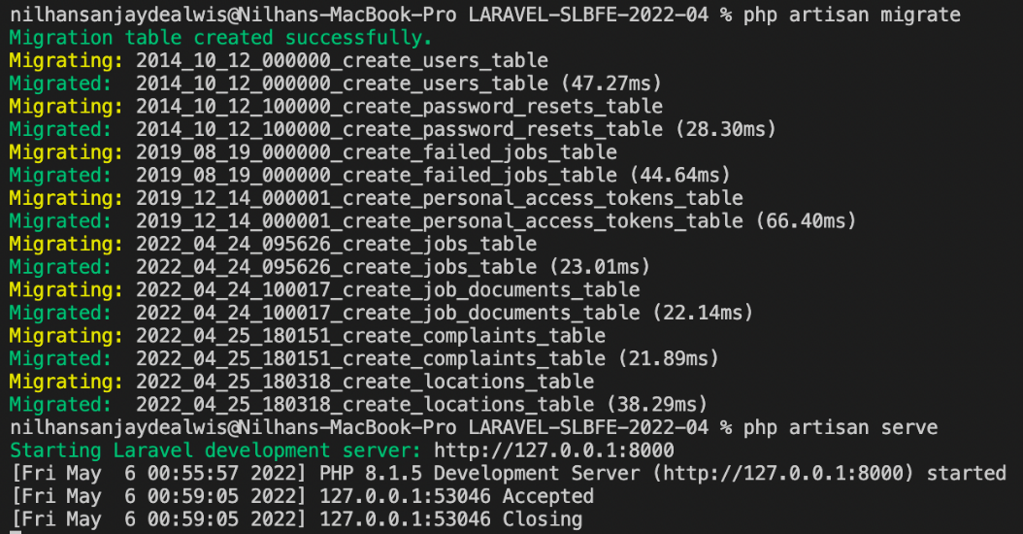

Figure 1: Type "php artisan migrate"



Figure 2: Type "php artisan migrate"

Next, when running the Client Application, it must be served in a different port. Since the API is running in port 8000, the Client Application should run on port 8001. For that, we type the following code:



Figure 3: Type "php artisan serve –port=8001"

Now let us configure the database.

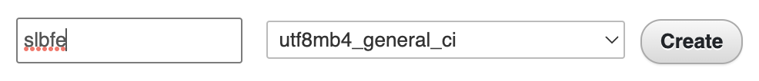

Figure 4: database configuration

After clicking, the following rows will be visible.

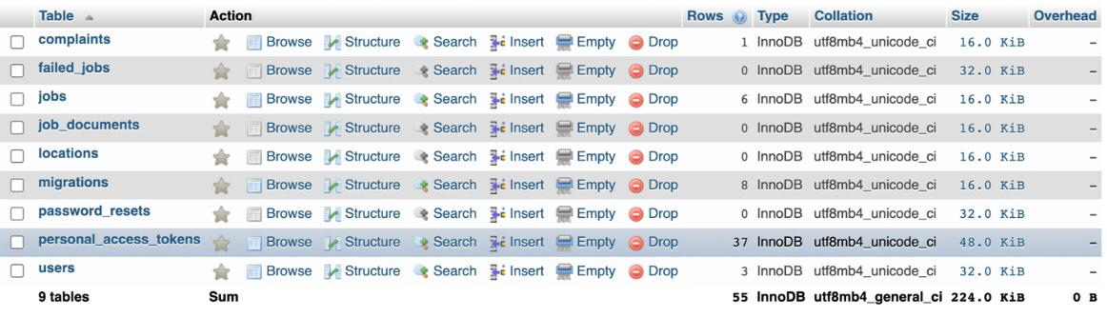

Figure 5: Database Table

# Project Scope

The project scope mainly caters towards bestowing the Sri Lankan citizens with productive employment opportunities.

## Citizens

Citizens possess the volition to Sign Up or Sign In through the Website or Mobile Application. They must fill in their login credentials to access their user account. Those who aren’t registered as a member must undergo the registration process. After logging in, they must update their respective qualifications and uploading their CV’s, birth certificate, etc. so that they can seek jobs offers. Citizens also could file a complaint, and bureau officers should be able to see it and respond appropriately. Once a citizen has left for foreign employment, they are required to update their current location as soon as they visit the company.

## Bureau Officers (acts as an admin)

Bureau Officers act as an admin, holding the power to be able to validate and review the profiles of the already created user accounts. They can also admin can block any citizen. Bureau Officers act like an intermediate between the Citizens and Foreign Companies. This is because they parallelly help the Citizens find suitable work outside of the country, while also helping Foreign Companies find appropriate workers.

Bureau Officers can also respond to any complaints made by the respective Citizens. The Bureau Officers also checks into the foreign employee’s overall safety and wellbeing.

## Foreign Companies Employers

Within the boundaries of this project, Foreign Companies are government approved companies that look forward to recruit and employ skilled employees from Sri Lanka. Foreign Companies can select employees based on their respective qualifications.

# System Architecture

## Data Flow Diagram Level 0

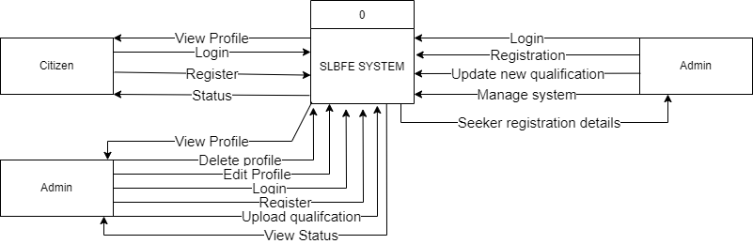

Figure 6: Context Diagram

## Data Flow Diagram Level 1

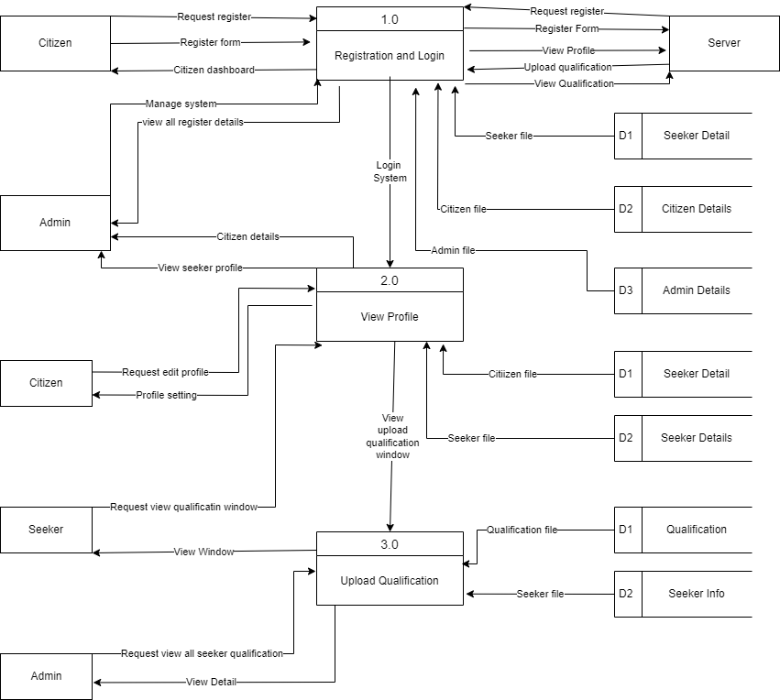

Figure 7: Data flow diagram - Level 1

## Use Case Diagram

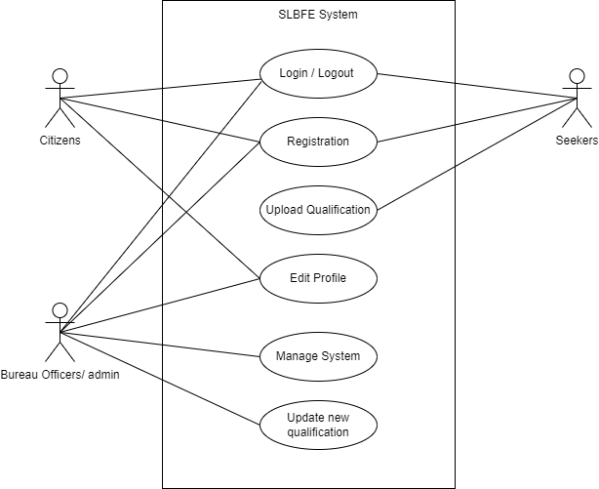

Figure 8: Use case Diagram

## Class Diagram

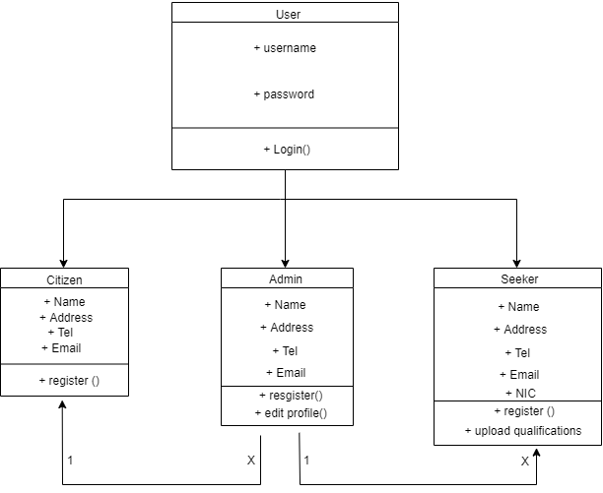

Figure 9: Class Diagram

## Entity Diagram

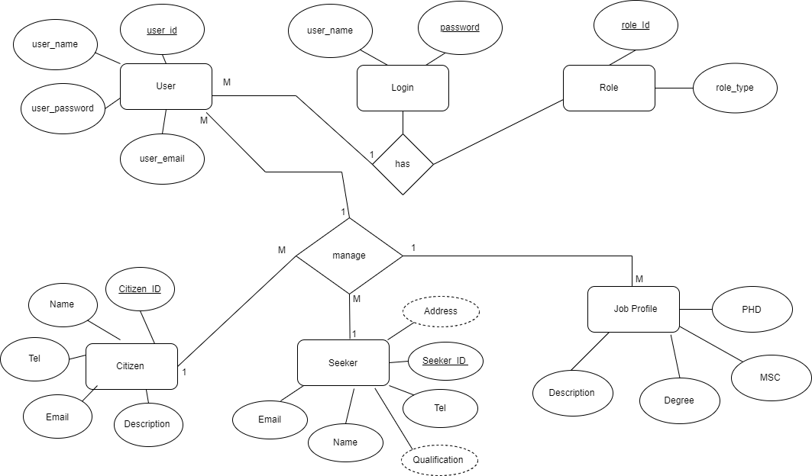

Figure 10: Entity Diagram

## Flow Chart

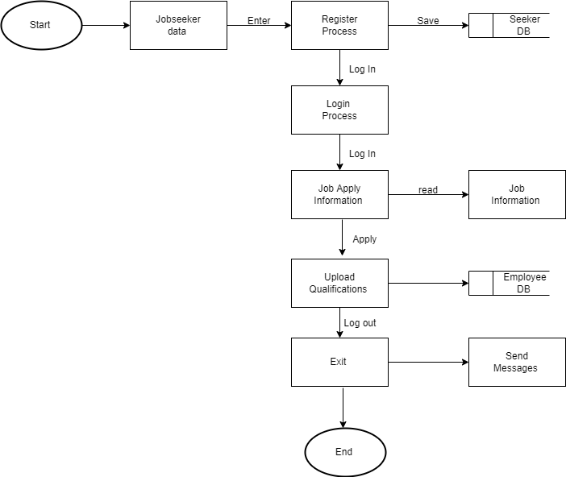

Figure 11: Flow chart

# API Documentation

With the utilization of a RESTful API, we have successfully developed both the Web and Mobile Application. Furthermore, we have authorized a capability for Citizen’s to get themselves registered into the system’s Database through either the Web and Mobile Application.

Presented right below are the API’s constructed to suit the functional requirements of both the Web and Mobile Applications.

## POST /citizens

Both Citizens and Bureau Officers hold the capability to register themselves with following details:

* National ID (NIC)
* Name
* Age
* Address
* Current Location (latitude and longitude)
* Profession
* Email
* Affiliation
* Password, retype Password

Route::post('register', [AuthController::class, 'register']);

Route::post('login', [AuthController::class, 'login']);

## PUT /citizens/:nid

Job seekers should be able to update their qualifications and upload certificates.

Route::put('vacancy/add', [JobController::class, 'addVacancy']);

Route::put('location/add', [JobController::class, 'location']);

Route::put('complaints/add', [ComplaintsController::class, 'add']);

Route::put('complaints/reply', [ComplaintsController::class, 'reply']);

## GET /citizens/:nid

Bureau Officers is able to access any citizen’s information by their National ID (NIC).

Route::get('vacancy/list', [JobController::class, 'listVacancy']);

Route::get('qualification/get', [JobController::class, 'getQualifications']);

Route::get('qualification/search', [JobController::class, 'searchQualifications']);

Route::get('complaints/get', [ComplaintsController::class, 'get']);

Route::get('users/get', [UserController::class, 'get']);

## PUT /citizens/:nid

Bureau Officers can verify, validate and review the profiles of the already created user accounts.

## GET /citizens/find(:qualifications)

Foreign Company Officers can find candidates based on the Citizens respective qualifications.

## DELETE /citizens/:nid

SLBFE staff (Bureau Officers) are able to deactivate an individual’s account if the Citizen is deceased (or for any other suitable reason).

Route::delete('users/delete', [UserController::class, 'delete']);

## GET /citizens/:nid/contacts

SLBFE staff can collect information regarding contacts of any Citizen.

## JSON Requests and Responses

## XML requests and responses

# Tools and technologies

In pursuance of securing a successful project outcome, we have contended in carefully choosing the most suitable tools and technologies.

When it comes to developing the API, we have utilized PHP based Laravel framework. The Web Application also uses the same framework.

We have used Android Studios to create our mobile application. Android Studios uses SDK (specified for android technologies). Furthermore, we have also selected Java as the coding language for the Mobile Application. With the use of Android Studios, developers like us can successfully create high-performance products. Developers can also build emulators in accordance to their preference. These emulators are nimble and rich in features. Various testing mechanisms can also be deployed to test and maintain projects.

## PhpMyAdmin

As PHP is utilized to code the Web Application, it was more coherent to utilize PhpMyAdmin for MySQL database management. PhpMyAdmin is an open-source third-party software tool, written in PHP. The primary objective of utilizing phpMyAdmin is to superintend and operate the administration of MySQL over the web. It is also feasible to run CRUD operations like databases, copy, tables, rename, databases, tables, columns, etc.

phpMyAdmin can run on any server or any OS as it has a web browser.

With the utilization of phpMyAdmin, it is possible to edit, create or delete the database without much difficulty. In collation to the MySQL command-line editor, it is easier to manage elements with the utilization of the phpMyAdmin graphical interface. Several servers can also be operated simultaneously. Data can also be exported into various formats like Word, PDF, SQL, XML, Spreadsheet, etc.

## Laravel

Laravel is a PHP framework that adheres to an MVC design pattern. It is possible to increase the overall web application scalability with the Laravel framework. The utilization of Laravel framework has been deemed time-saving, as the existing framework components that aid in the creation of the web application is reused. When it comes to developing the API, we have utilized PHP based Laravel framework, which also goes for the Web Application.

## PHP

With regards to PHP, it is a platform independent, open-source scripting language that is generally well suited for web development. It doesn’t matter whether it is a web application, dynamic website or static website. The code can be embedded to HTML in the server-side.

Due to its platform independency, it is permitted to be utilized on Windows, Linux, macOS, supporting almost all Web Browsers. Furthermore, it can also work with all major web servers, making it simpler to deploy on a variety of systems and platforms at a low cost.

PHP makes it easier to connect to almost any databases. This provided us more flexibility in deciding which database would be ideal for the application we were developing.

One of the other main reasons why we chose PHP is that it is very simple to get started with. Even without extensive knowledge or experience in the web development, our team could create a web page using PHP in short period of time. The syntax seems to be simple and learning the function is not hard, which means chances of errors are lower in PHP than other languages.

## XML

XML is a markup language that denotes a group of rules for data ciphering documents which can be understood by both humans and machines.

It majorly supports simplicity, generality, and usability and also simplifies shared storage, data transferring, data conformity, etc. Moreover, it permits the process of switching to new software or Operating Systems (OS) without misplacing any details.

## Java

Java has been utilized in the Mobile Application of our project due to its robustness, ease of use, and cross-platform development competencies. It is secure, straightforward, and easy to comprehend, making code implementation relatively easier. As it is an Object-Oriented Programming Language, OOPs concepts like abstraction, encapsulation and inheritance help in the enhancement of security. It is also compatible and platform-independent, meaning that code written once can be run anywhere else (on other systems that also possess Java). As it is a High-Level Programming Language, it has fewer and simpler syntaxes.

## JavaScript Object Notation (JSON)

For data transmission purposes, standard text-format is utilized to transmit data within Web Applications. As it is language-independent, its format is simple and straightforward for humans to understand (read and write). The syntax related to the JSON format is also commensurate to JavaScript object code. For this reason, JSON data can be acquired from JavaScript conversion. It is also uncomplicated when it considering data parsing.

# Sri Lanka Bureau of Foreign Employment (SLBFE)

Shown below is the Website Login Page. This Login Page is common to both the Admin and Citizens.

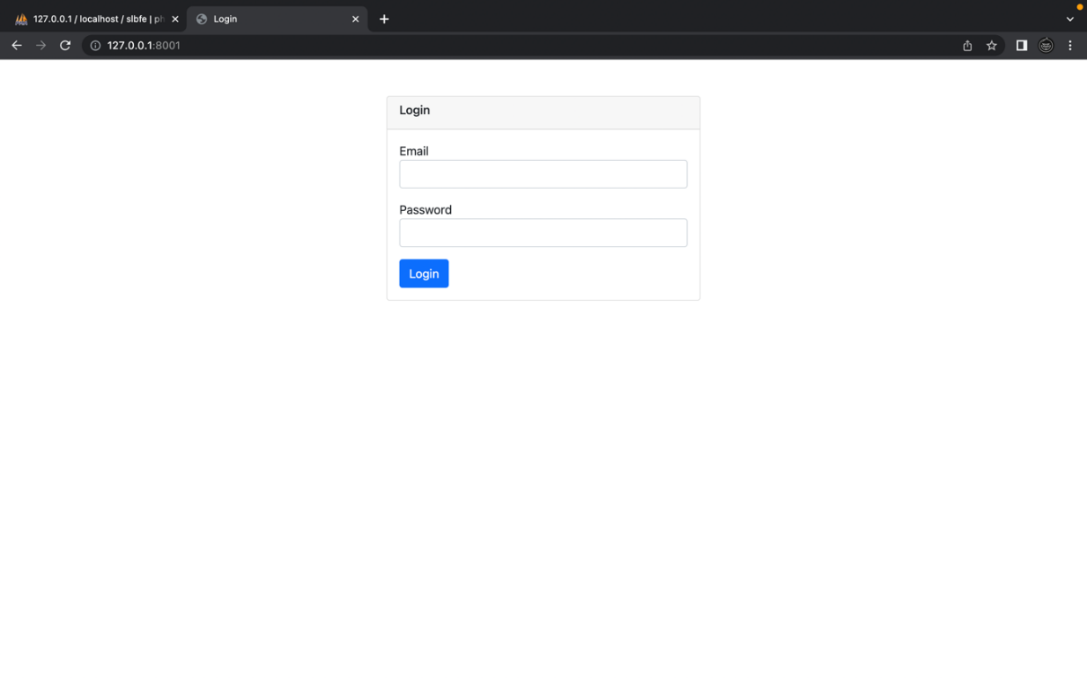

Figure 12: Login page in website

## Client Mobile Application Registration

The Citizen/User can get registered (free of charge) here in the Mobile Application.

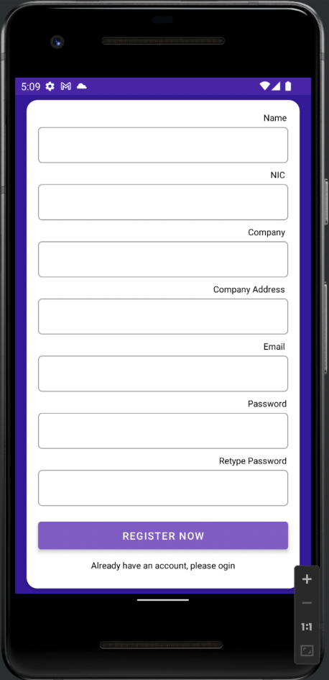

Figure 13: Mobile App Registration

Once the registration is completed and the process is successful, the “Registration Successful! Please Login” will be temporarily displayed.

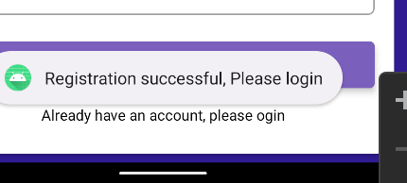

Figure 14: Toast for confirmation

Here, in the Mobile Application, any successfully registered Citizen can enter their credentials to Log In.

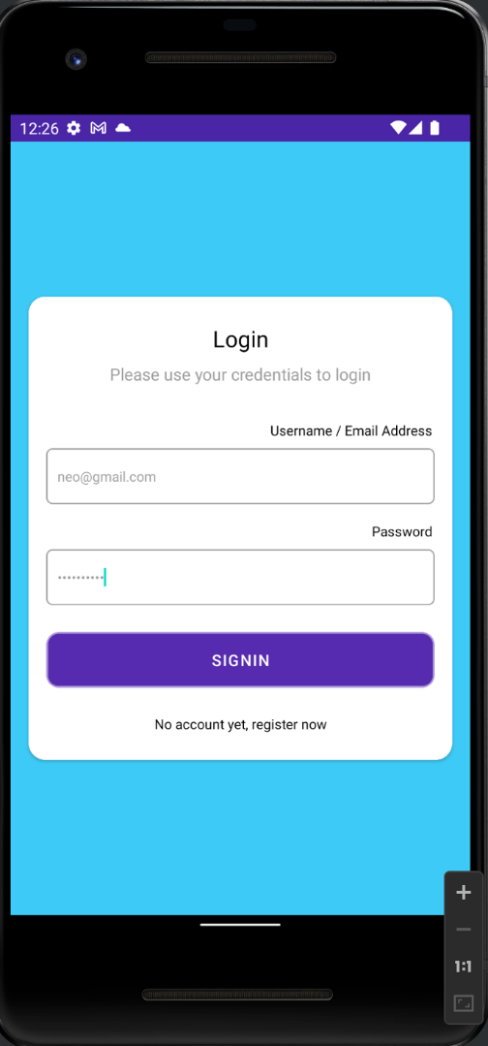

Figure 15: Mobile App Login page

Shown below is a Vacancy Screen that any registered Citizen/User will first see when logged in. They can seek and view available vacancies.

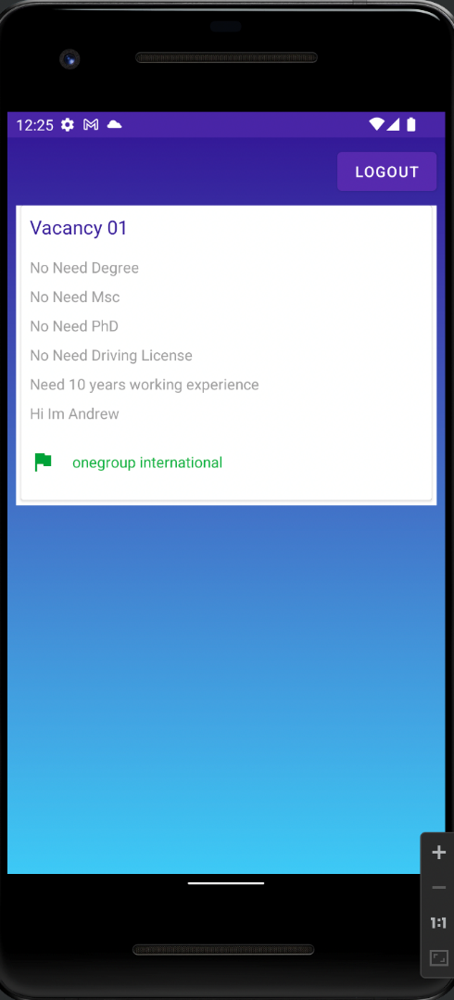

Figure 16: Mobile app Vacancy scree

## User/Client Website Features

Here, on the Website, the Citizen/User will first see their profile when logged in. They can update their credentials and qualifications by using their Qualifications profile page. The credentials and qualifications are:

* Has Degree
* Has MSc
* Has PhD
* Has License
* Working Experience
* Notes

Users are also able to choose and upload files. As an example, in the following screenshot, the user has selected and uploaded the Car jpg. image as shown.

They also have the ability to file complaints. Furthermore, there is a seekers page and a logout option, where once the user clicks the “Logout” button, they are logged out.

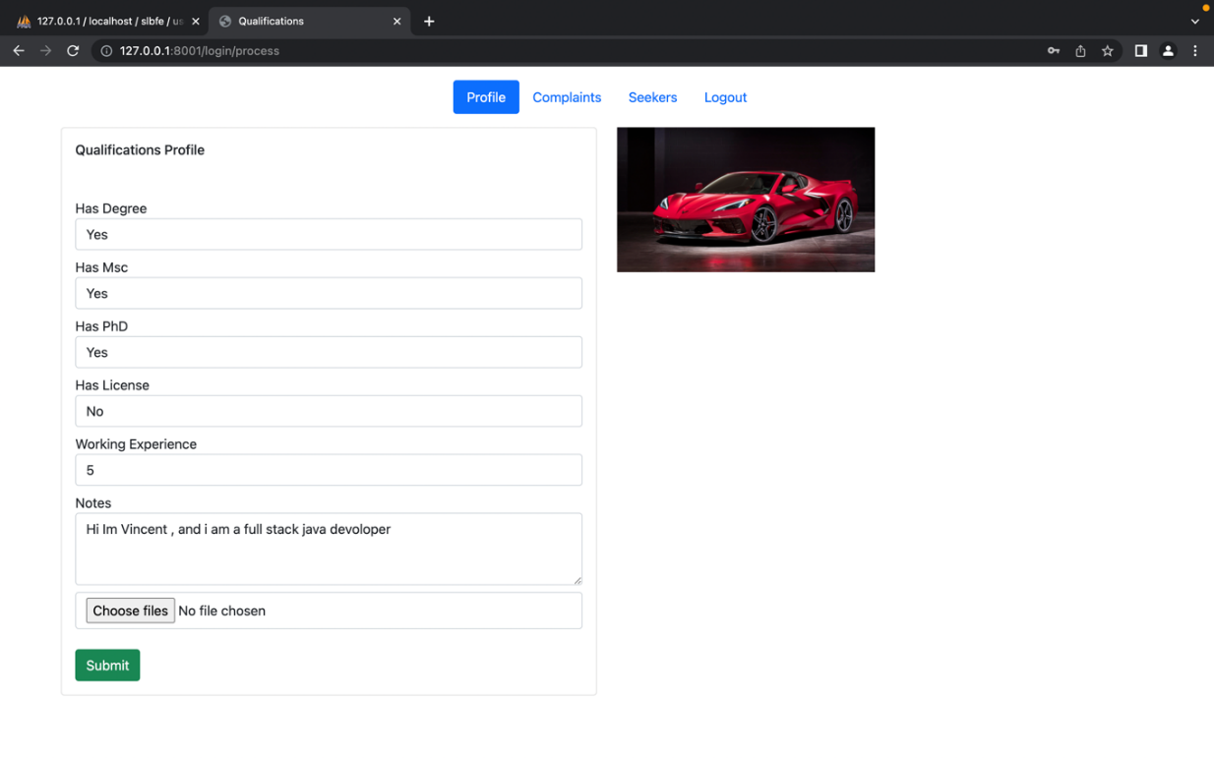

Figure 17: Citizen's profile updating page example

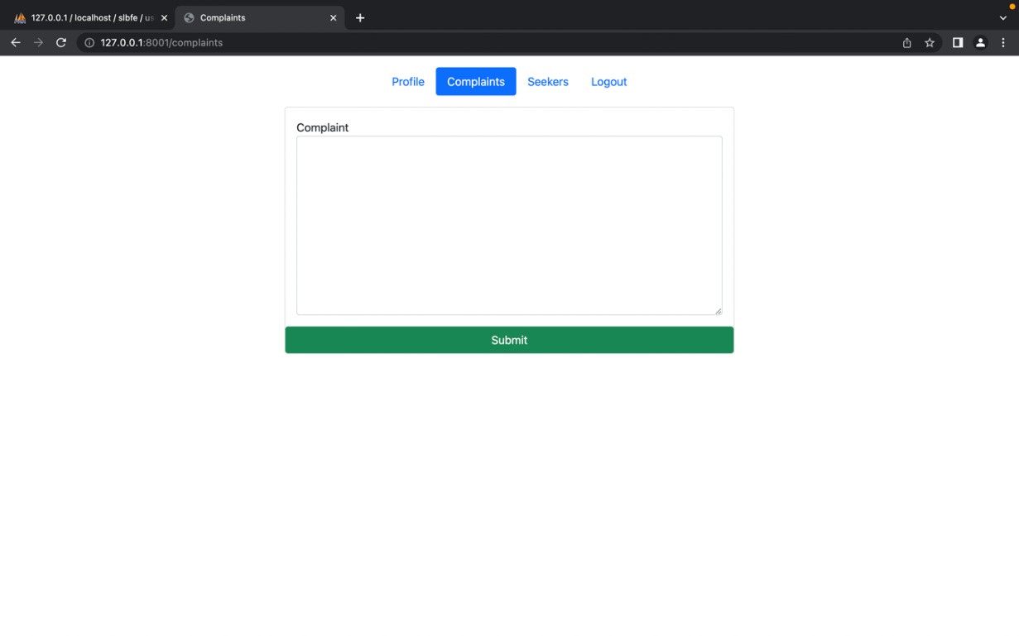

Figure 18: Complaints page

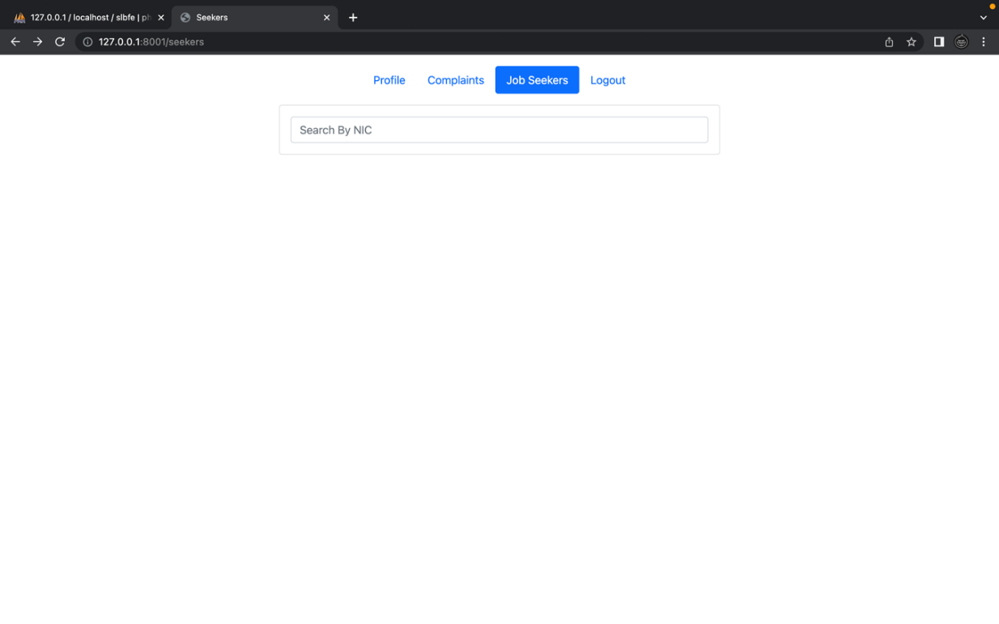

Figure 19: Job seekers

## Admin Website Features

The following screenshot presents the Bureau Officer’s (admin) page. They have access to:

### User Qualifications Profile

Here, the admin possesses the ability to manually input information for the clients/users that are about to received jobs.

### New Vacancy

New Vacancy is where the admin can advertise job opportunities. Here, the admin can relay the needs of the specific job post.

### Complaints

They are able to view and reply to the submitted complaints (relayed by users).

### Seekers

Under Seekers, they can view all User Profiles by simply searching up the registered user’s NIC.

### Users

Here, the admin can view user accounts and exercise blocking.

### Logout

Once, the admin clicks the “Logout” button, they are logged out.

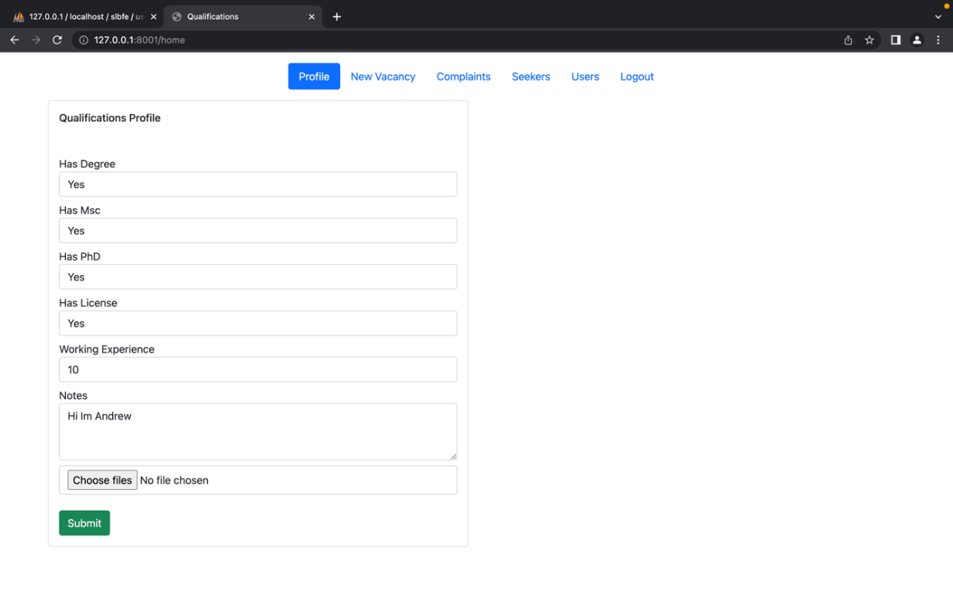

Figure 20: Admin side - create citizen profile

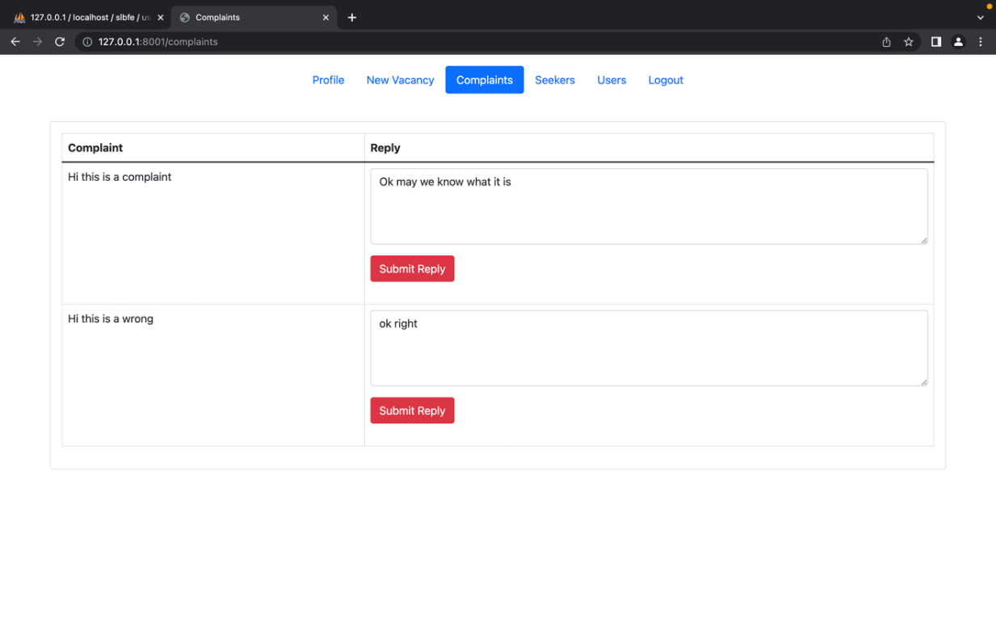

Figure 21: Replying complaints

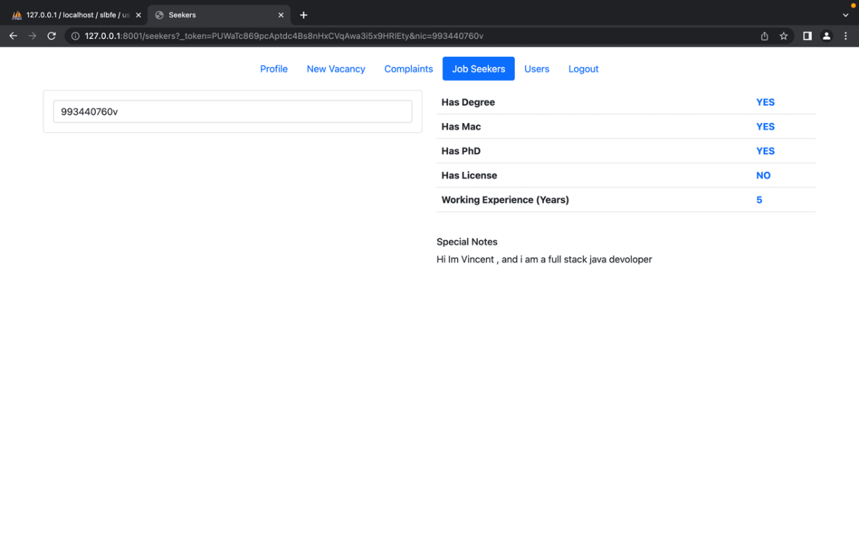

Figure 22: View Job seeker page

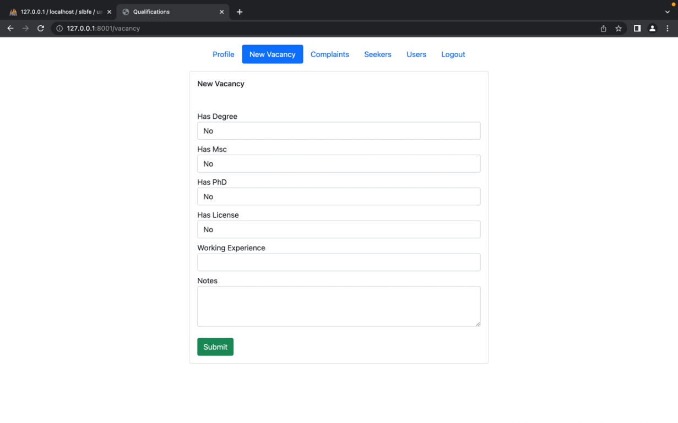

Figure 23: New Vacancy

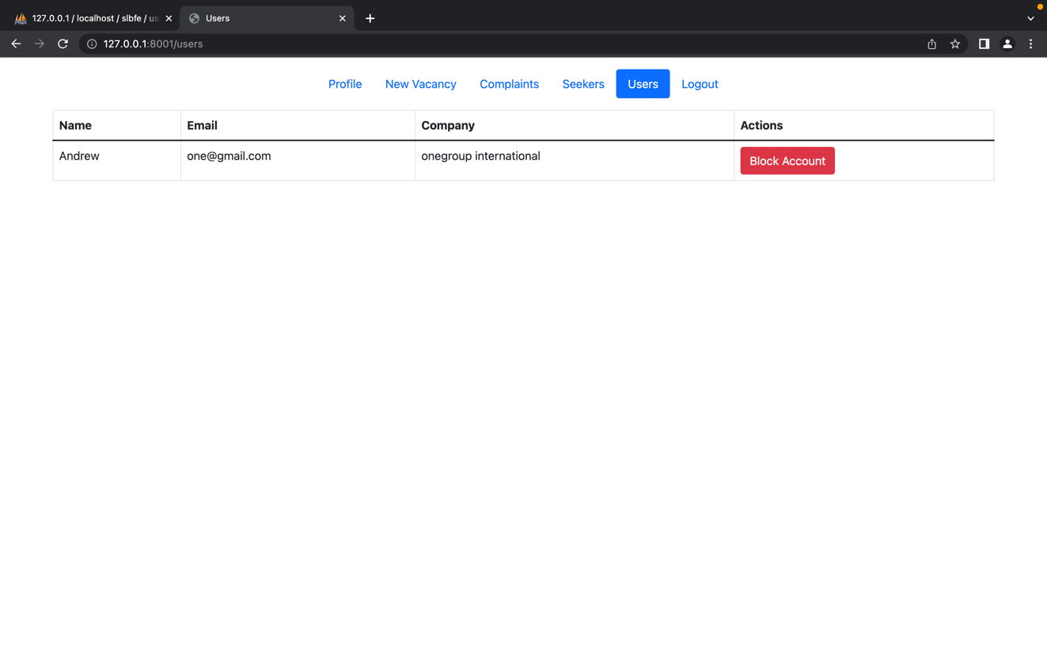

Figure 24: Manage Users

# Code Screenshots

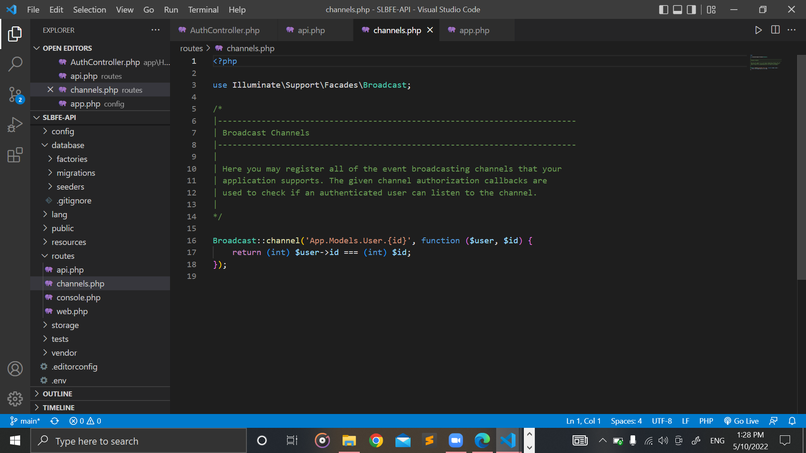

Figure 25: channels.php

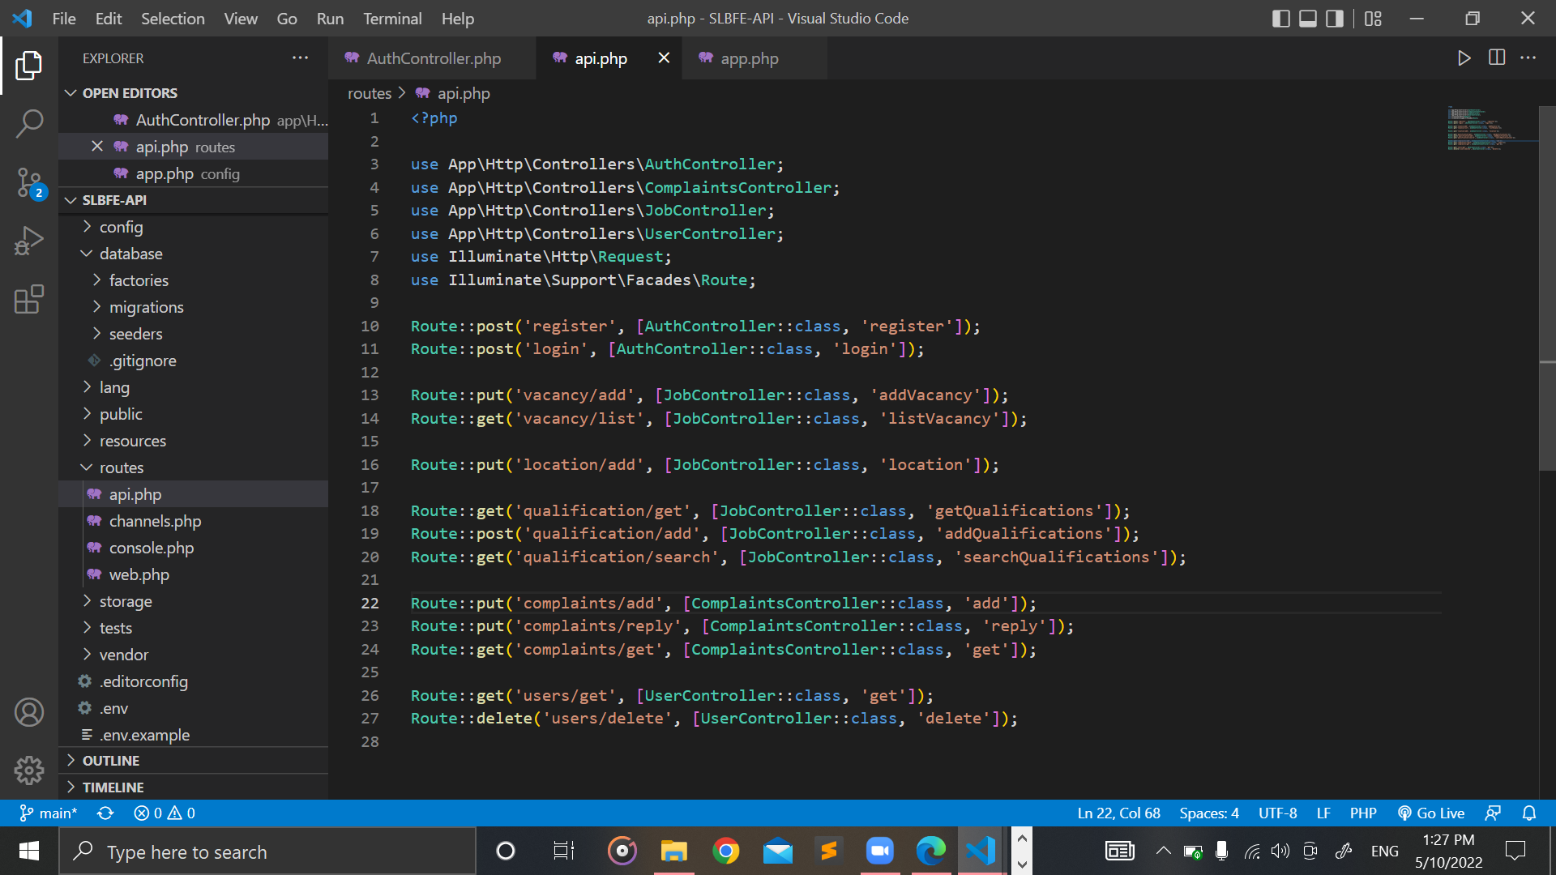

Figure 26: api.php

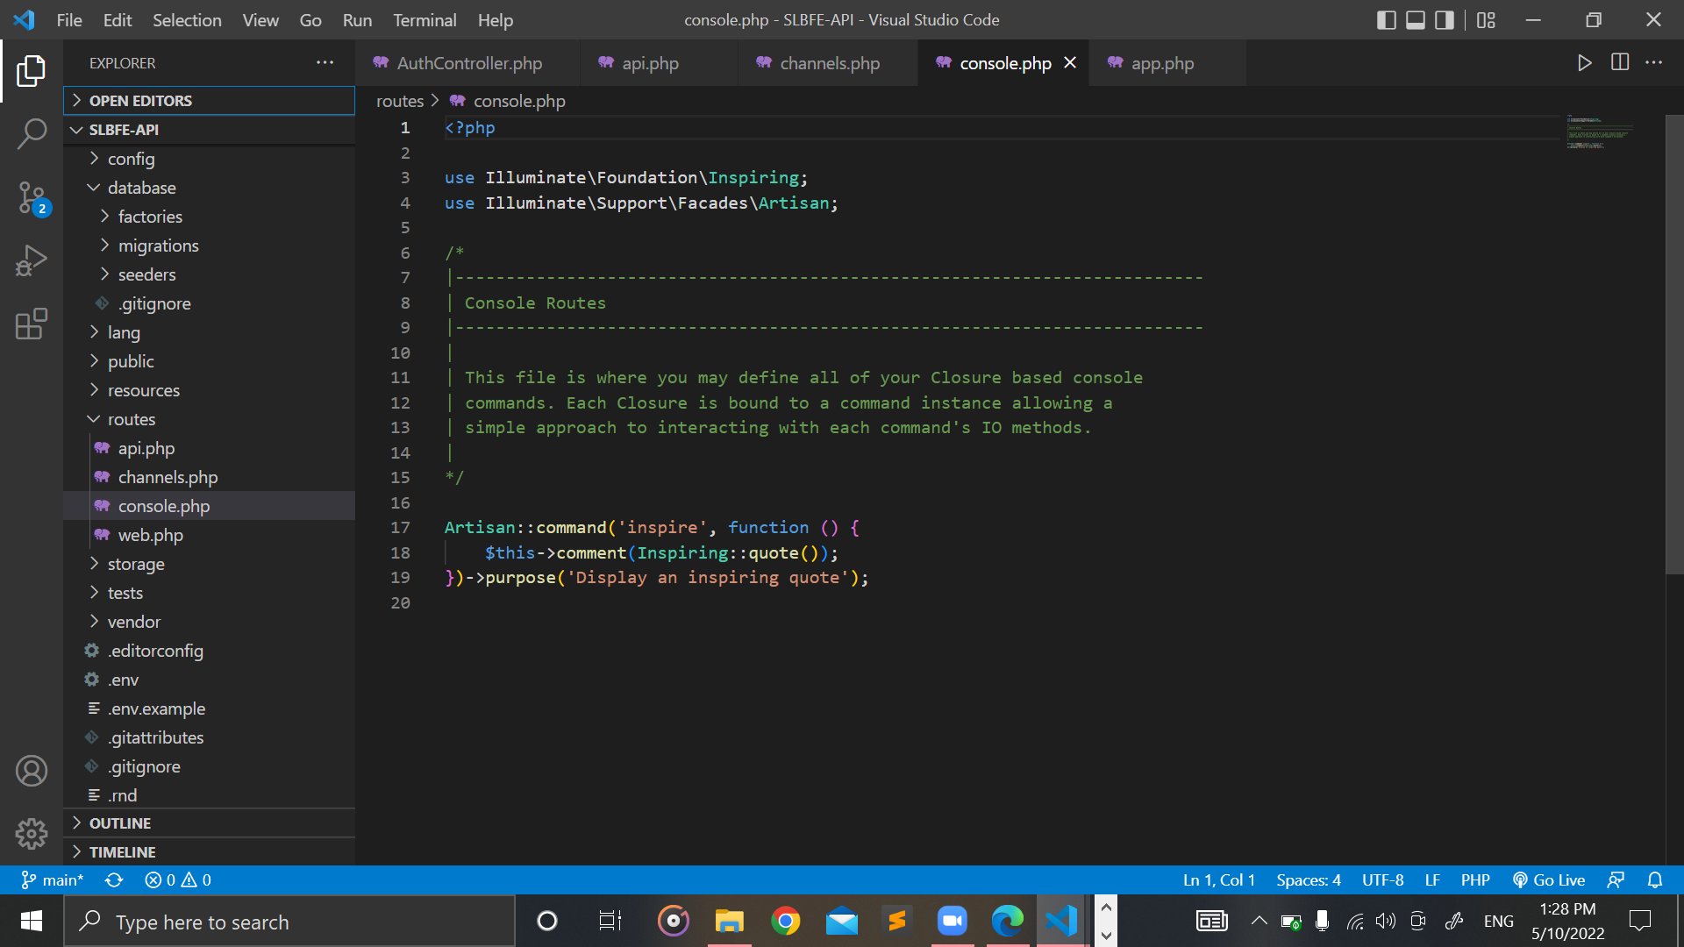

Figure 27: console.php

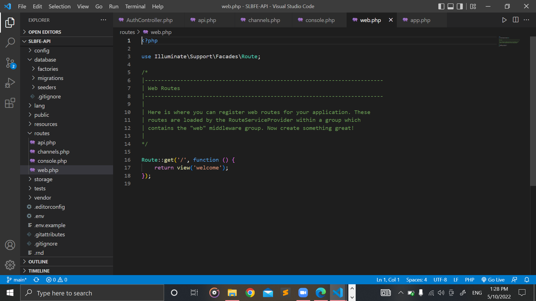

Figure 28: web.php

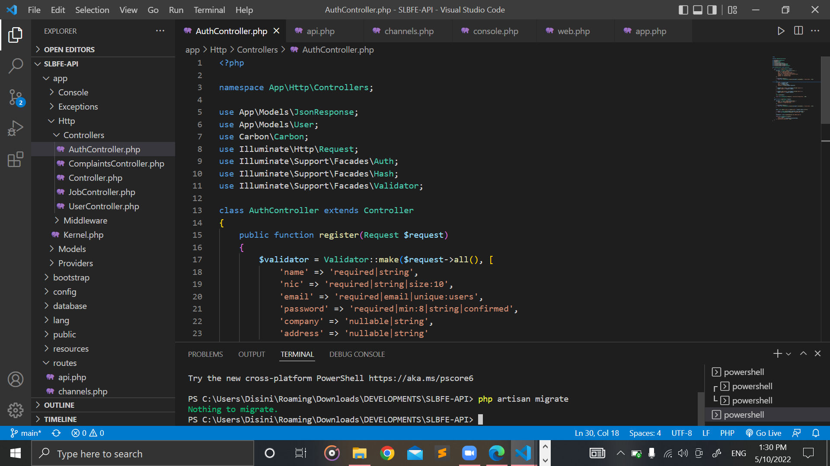

Figure 29: AuthController.php (Part 1)

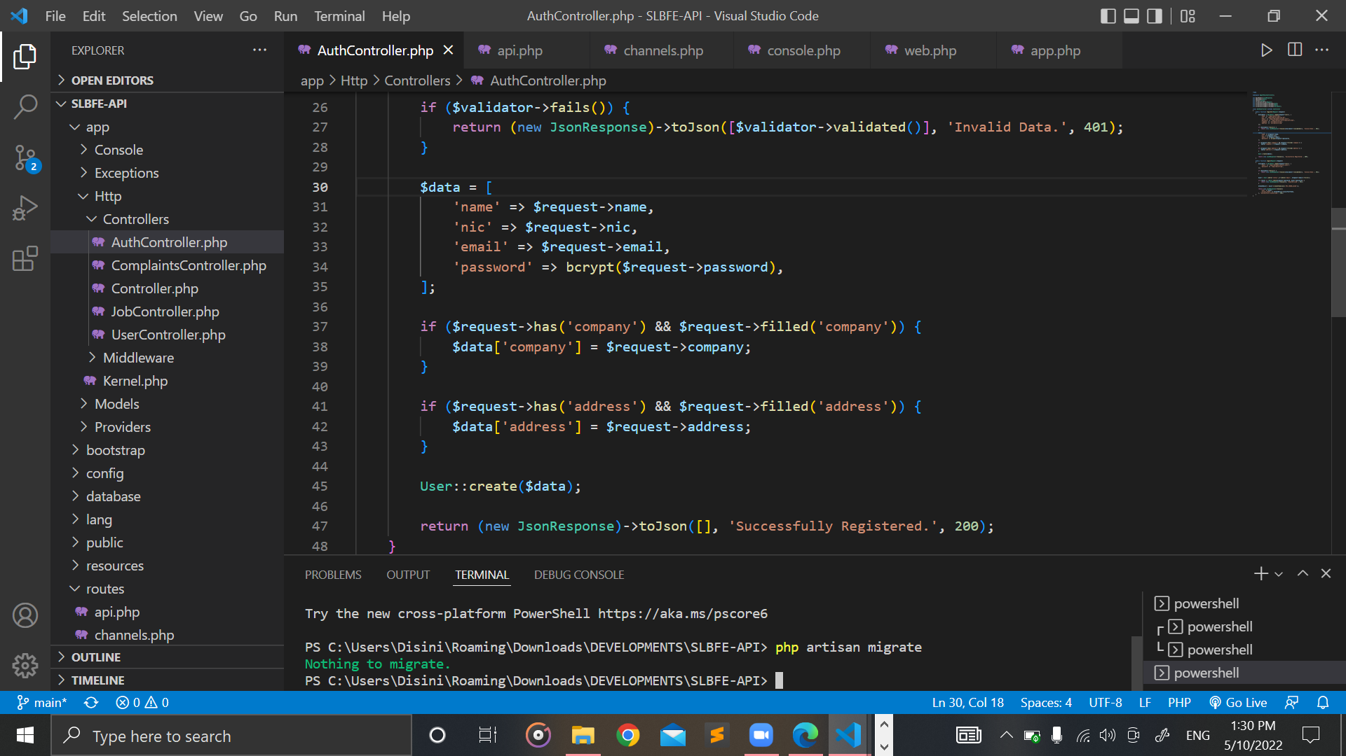

Figure 30: AuthController.php (Part 2)

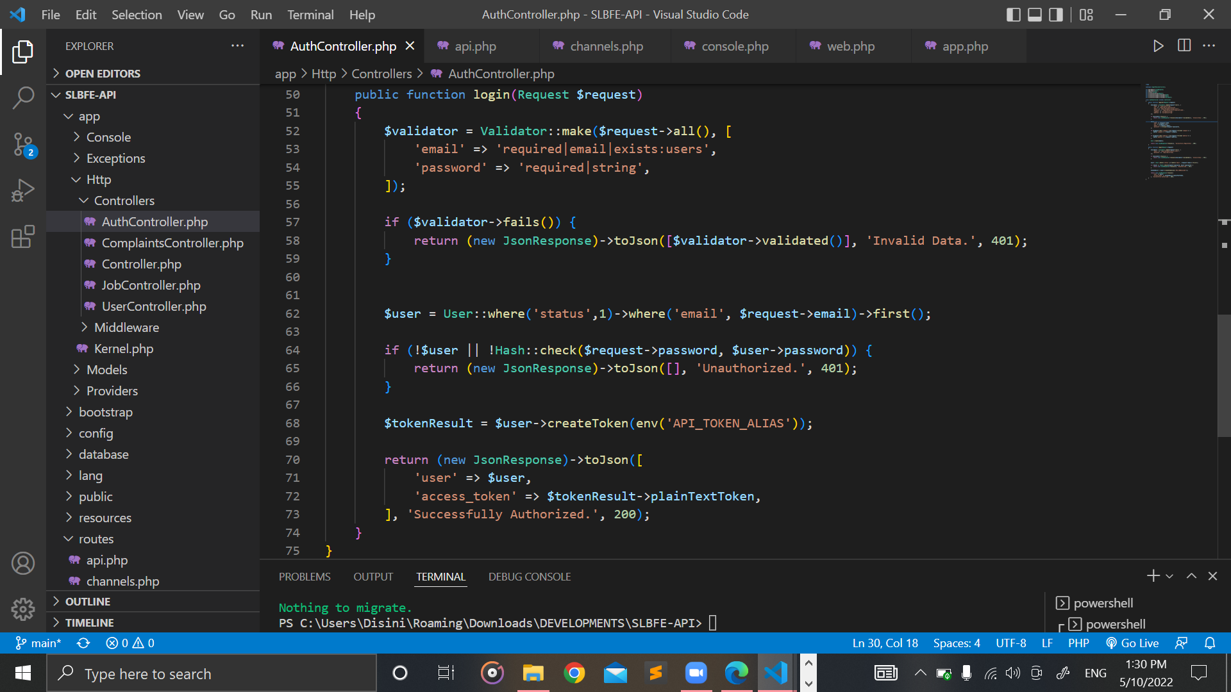

Figure 31: AuthController.php (Part 3)

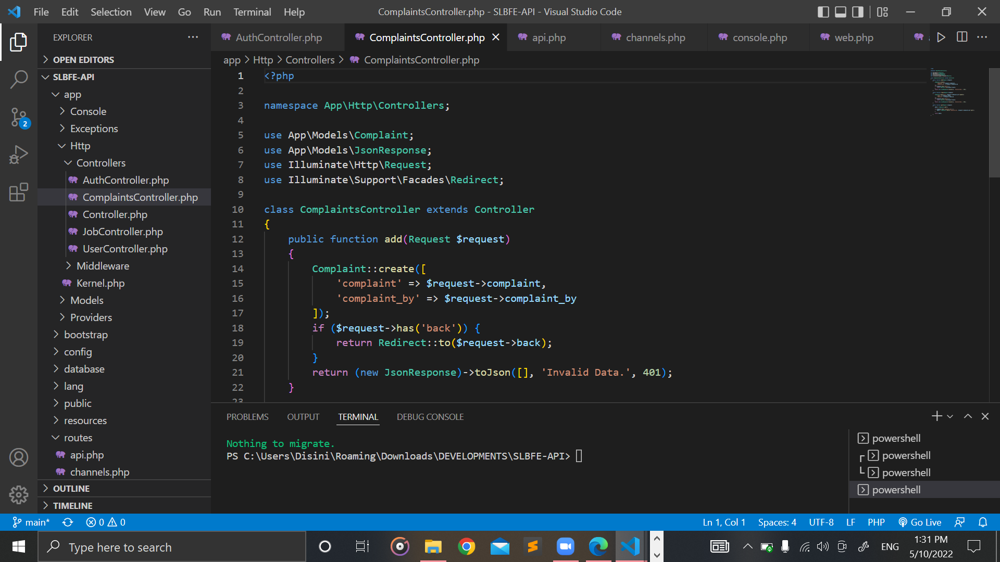

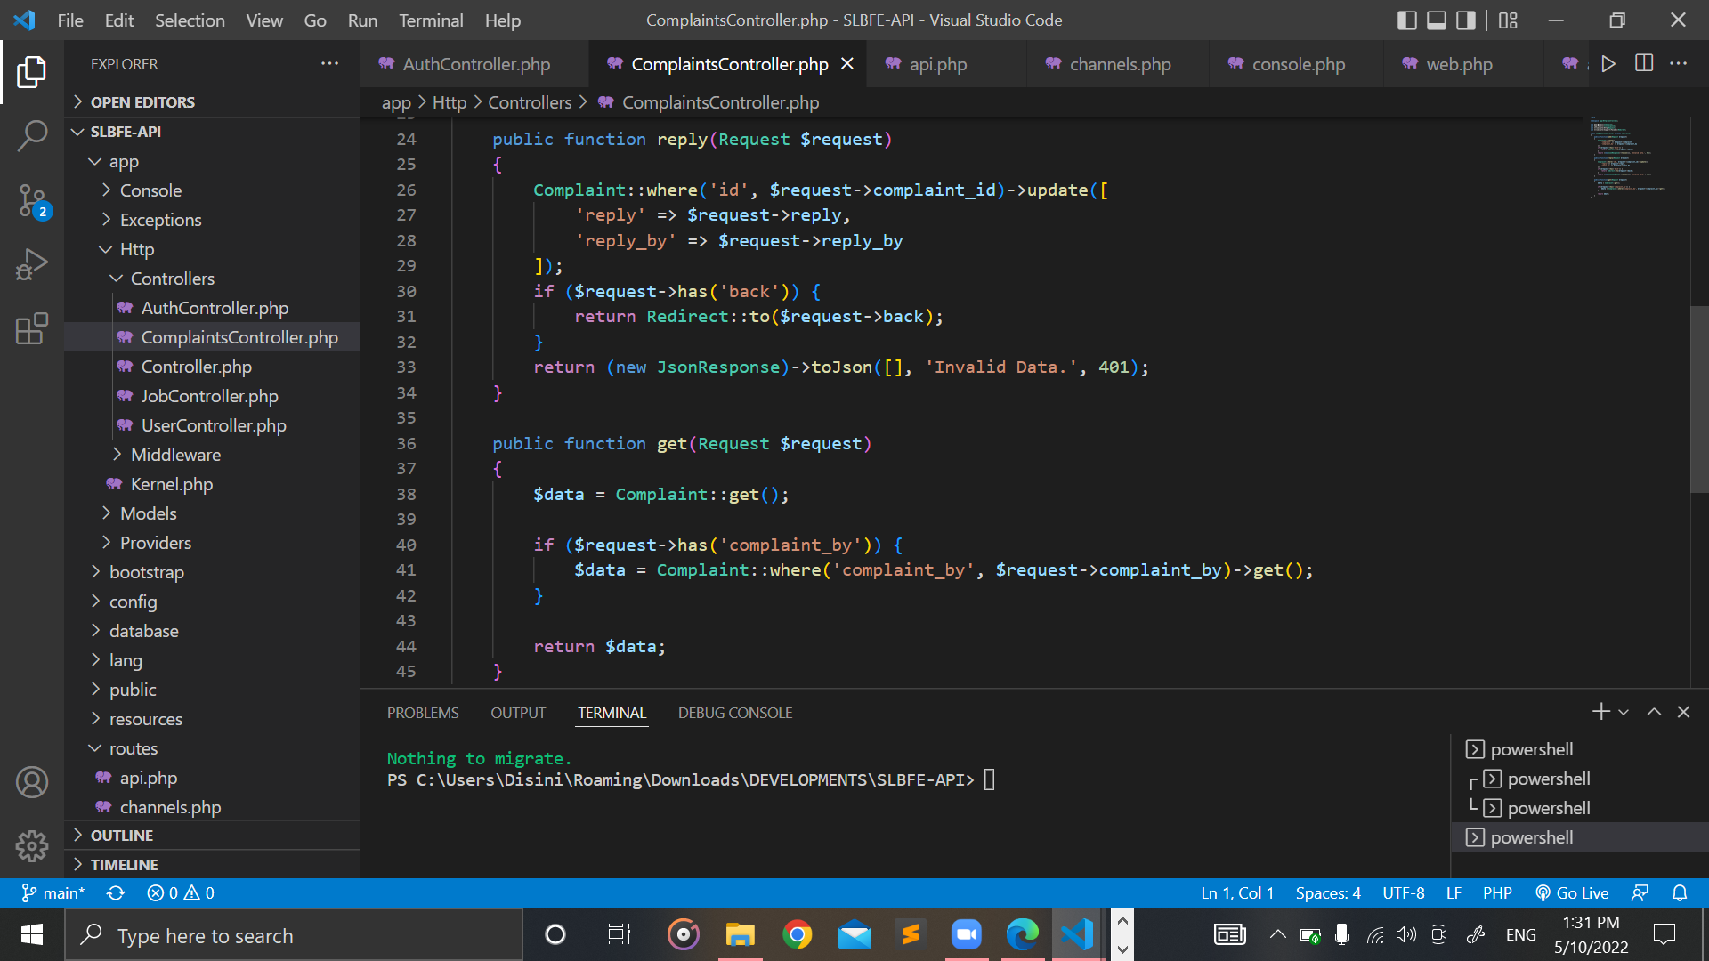

Figure 32: ComplaintsController.php

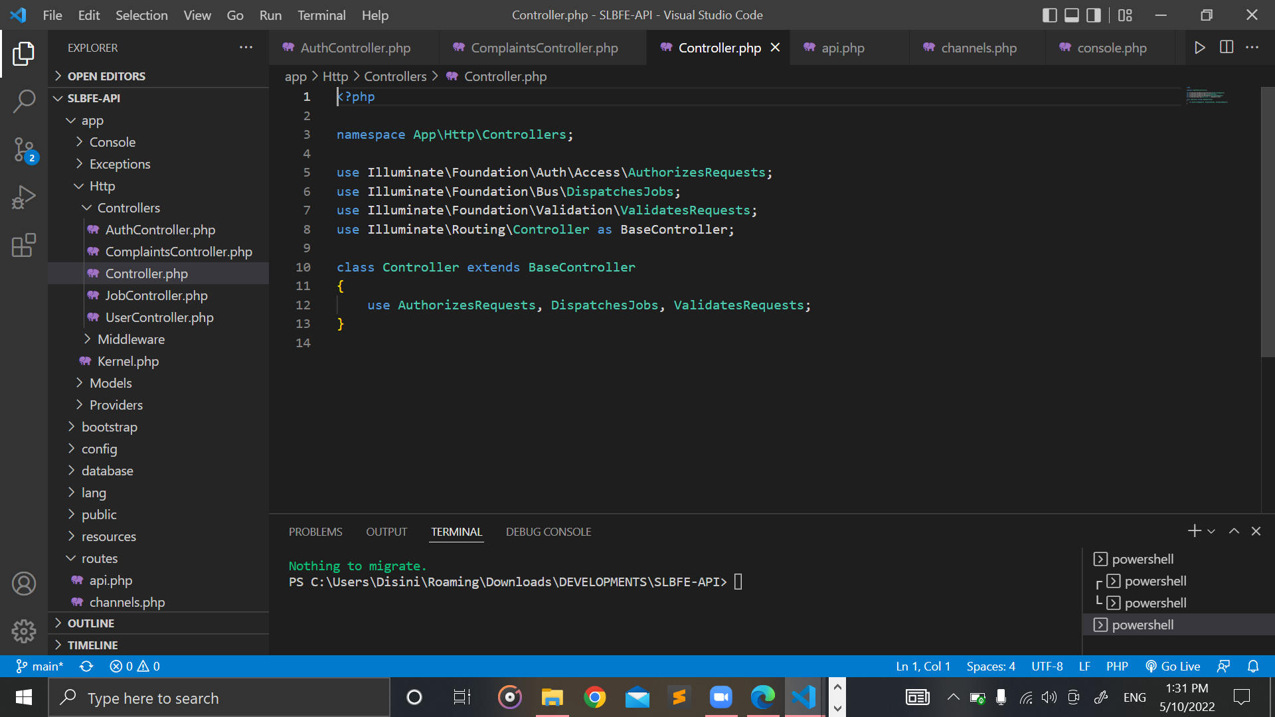

Figure 33: Controller.php

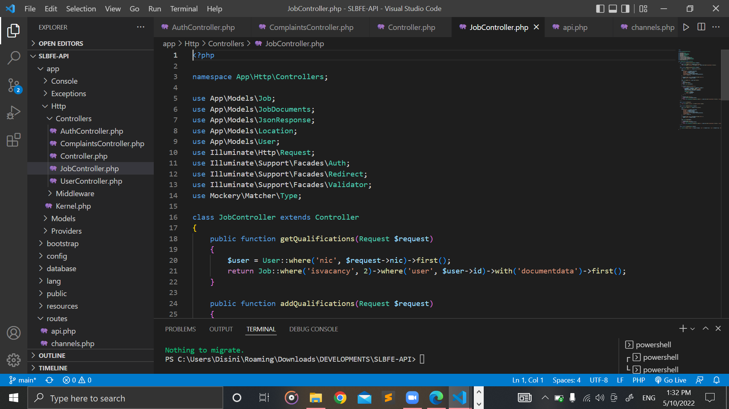

Figure 34: JobController.php

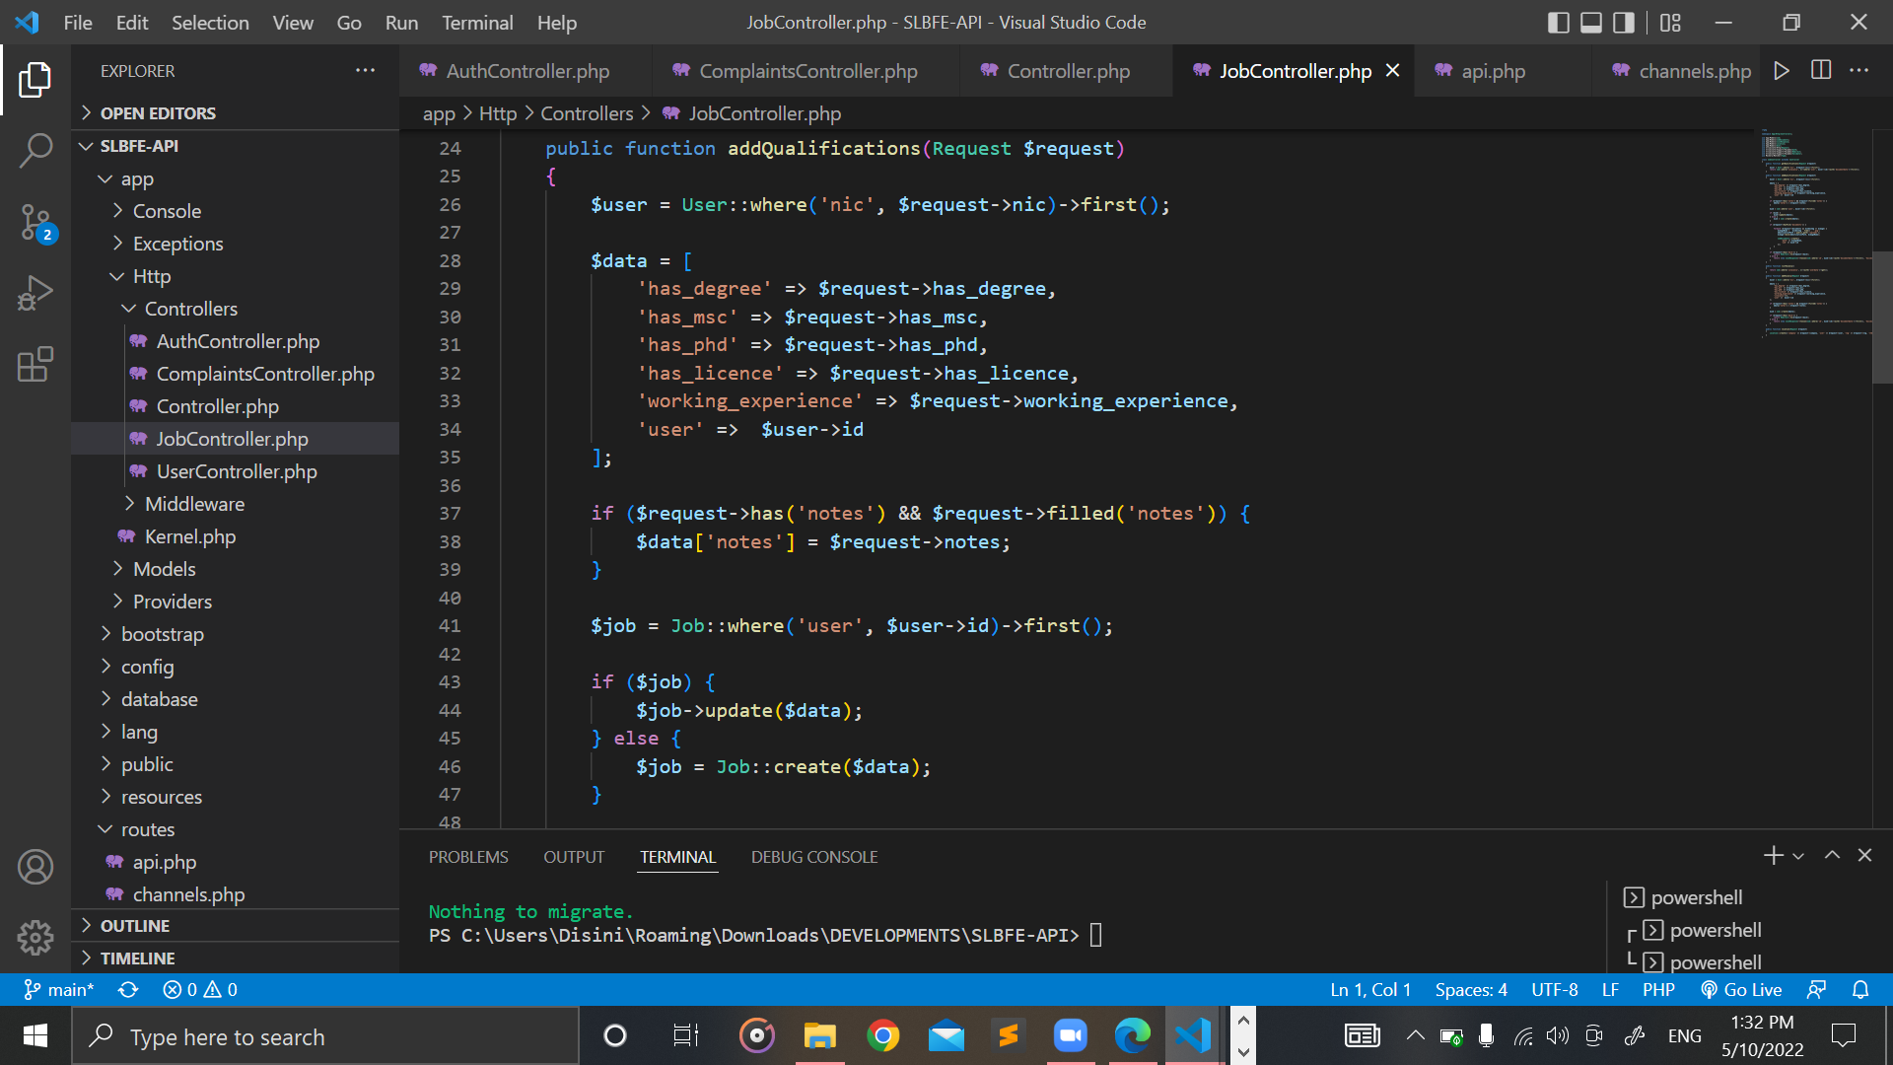

Figure 35: JobController.php (Part 2)

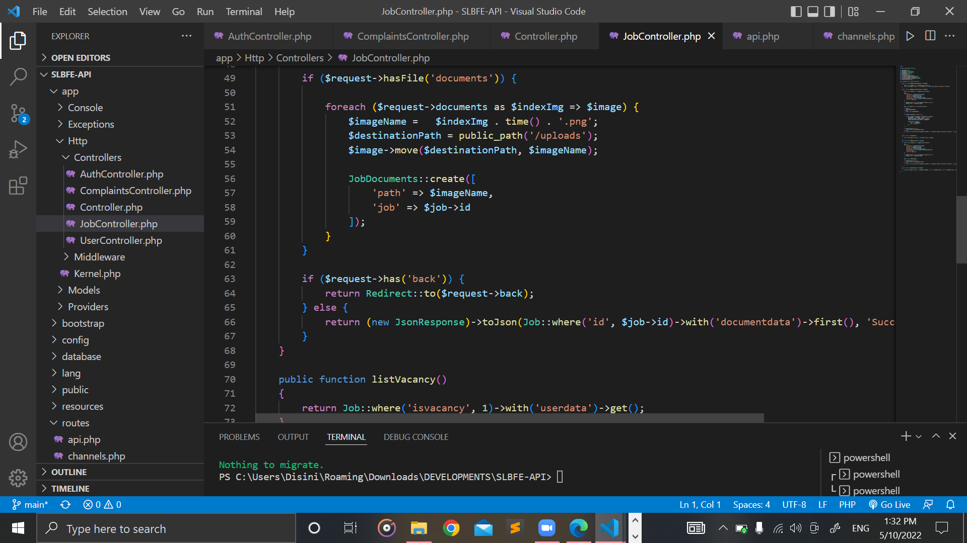

Figure 36: JobController.php (Part 3)

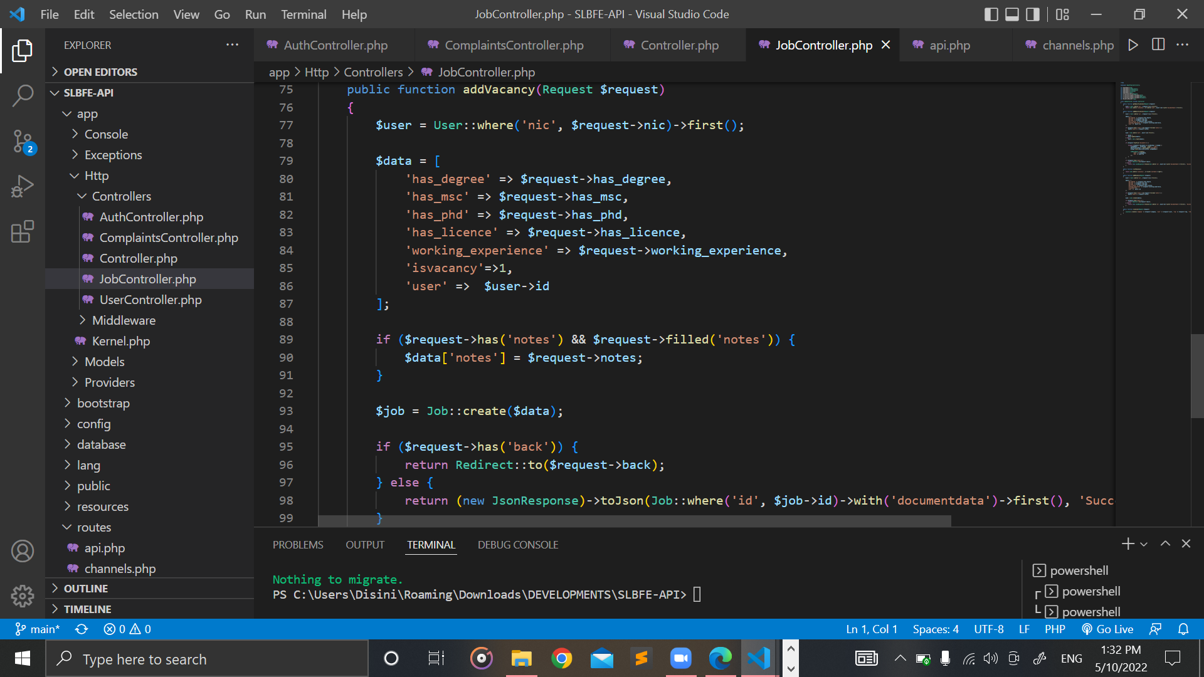

Figure 37: JobController.php (Part 3)

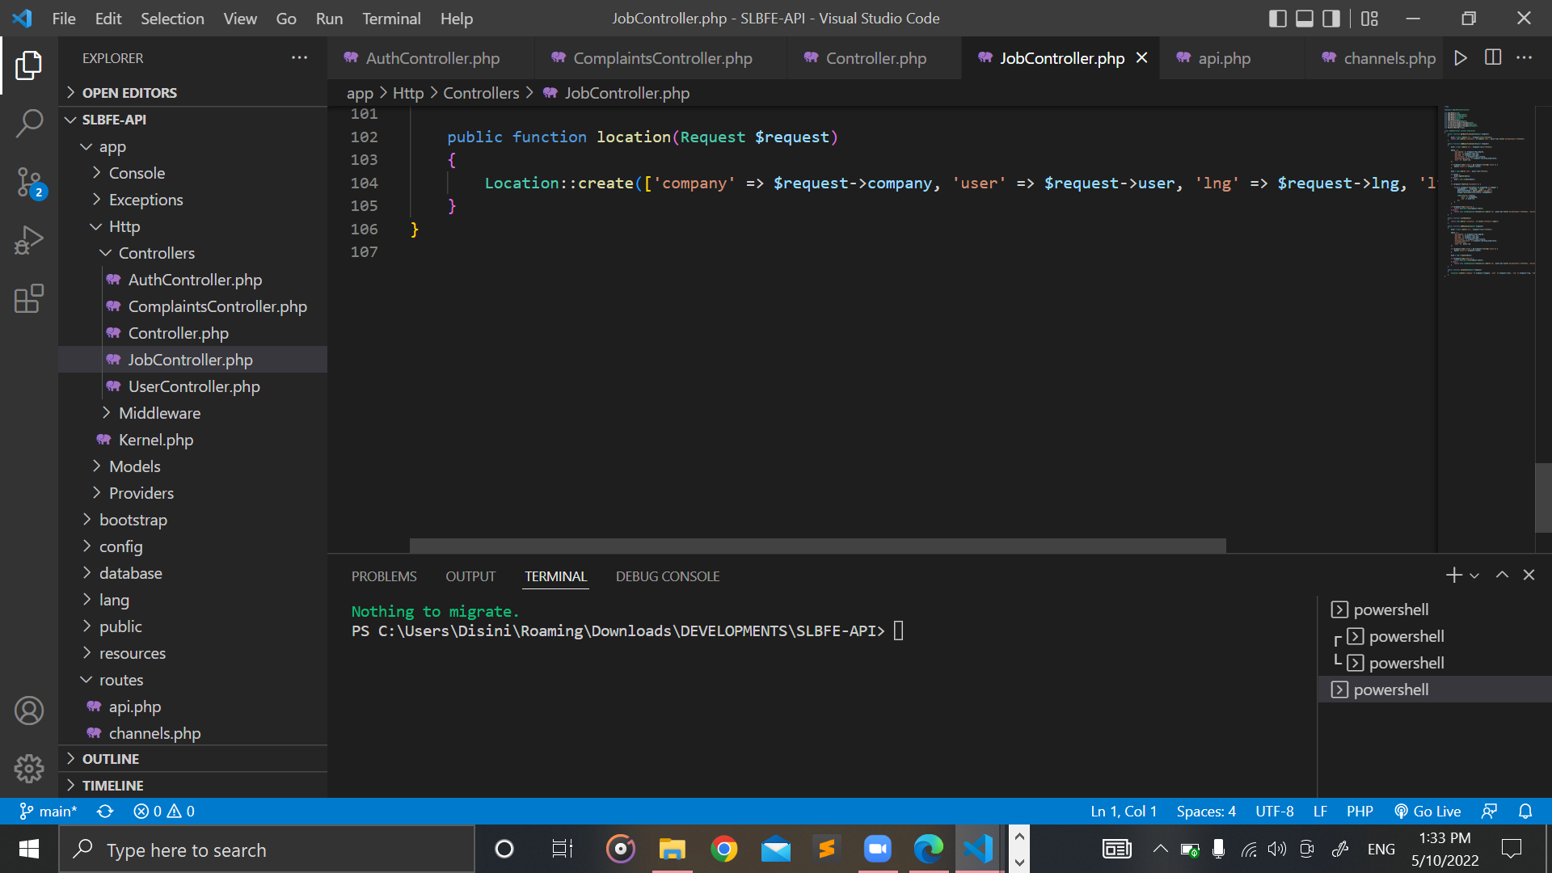

Figure 38: JobController.php (Part 4)

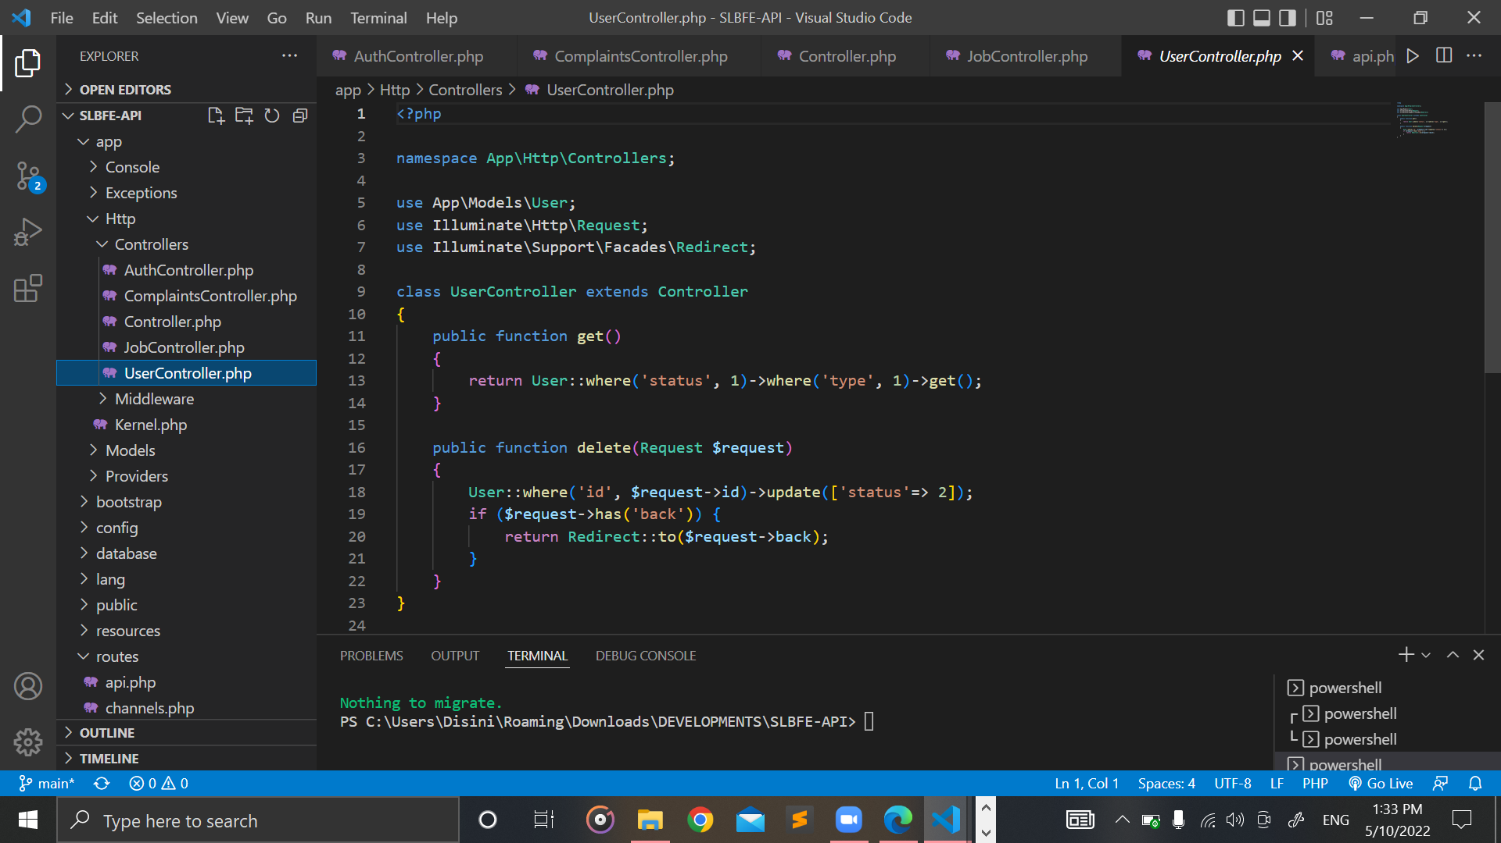

Figure 39: UserController.php

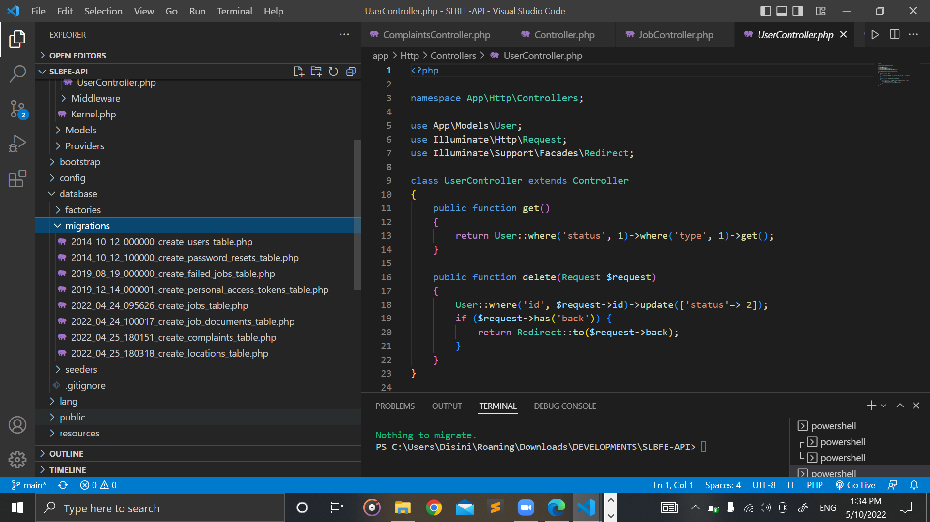

Figure 40: migrations folder

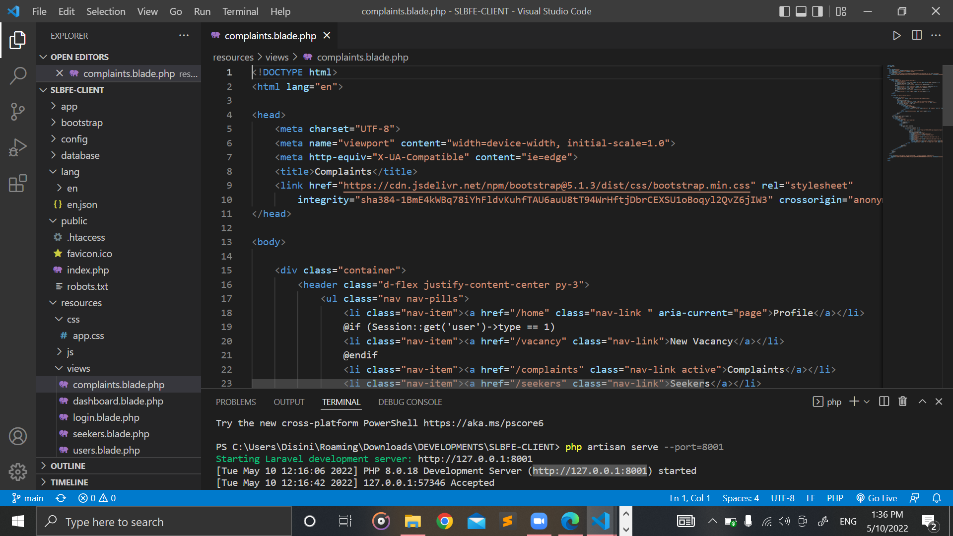

Figure 41: complaints.blade.php

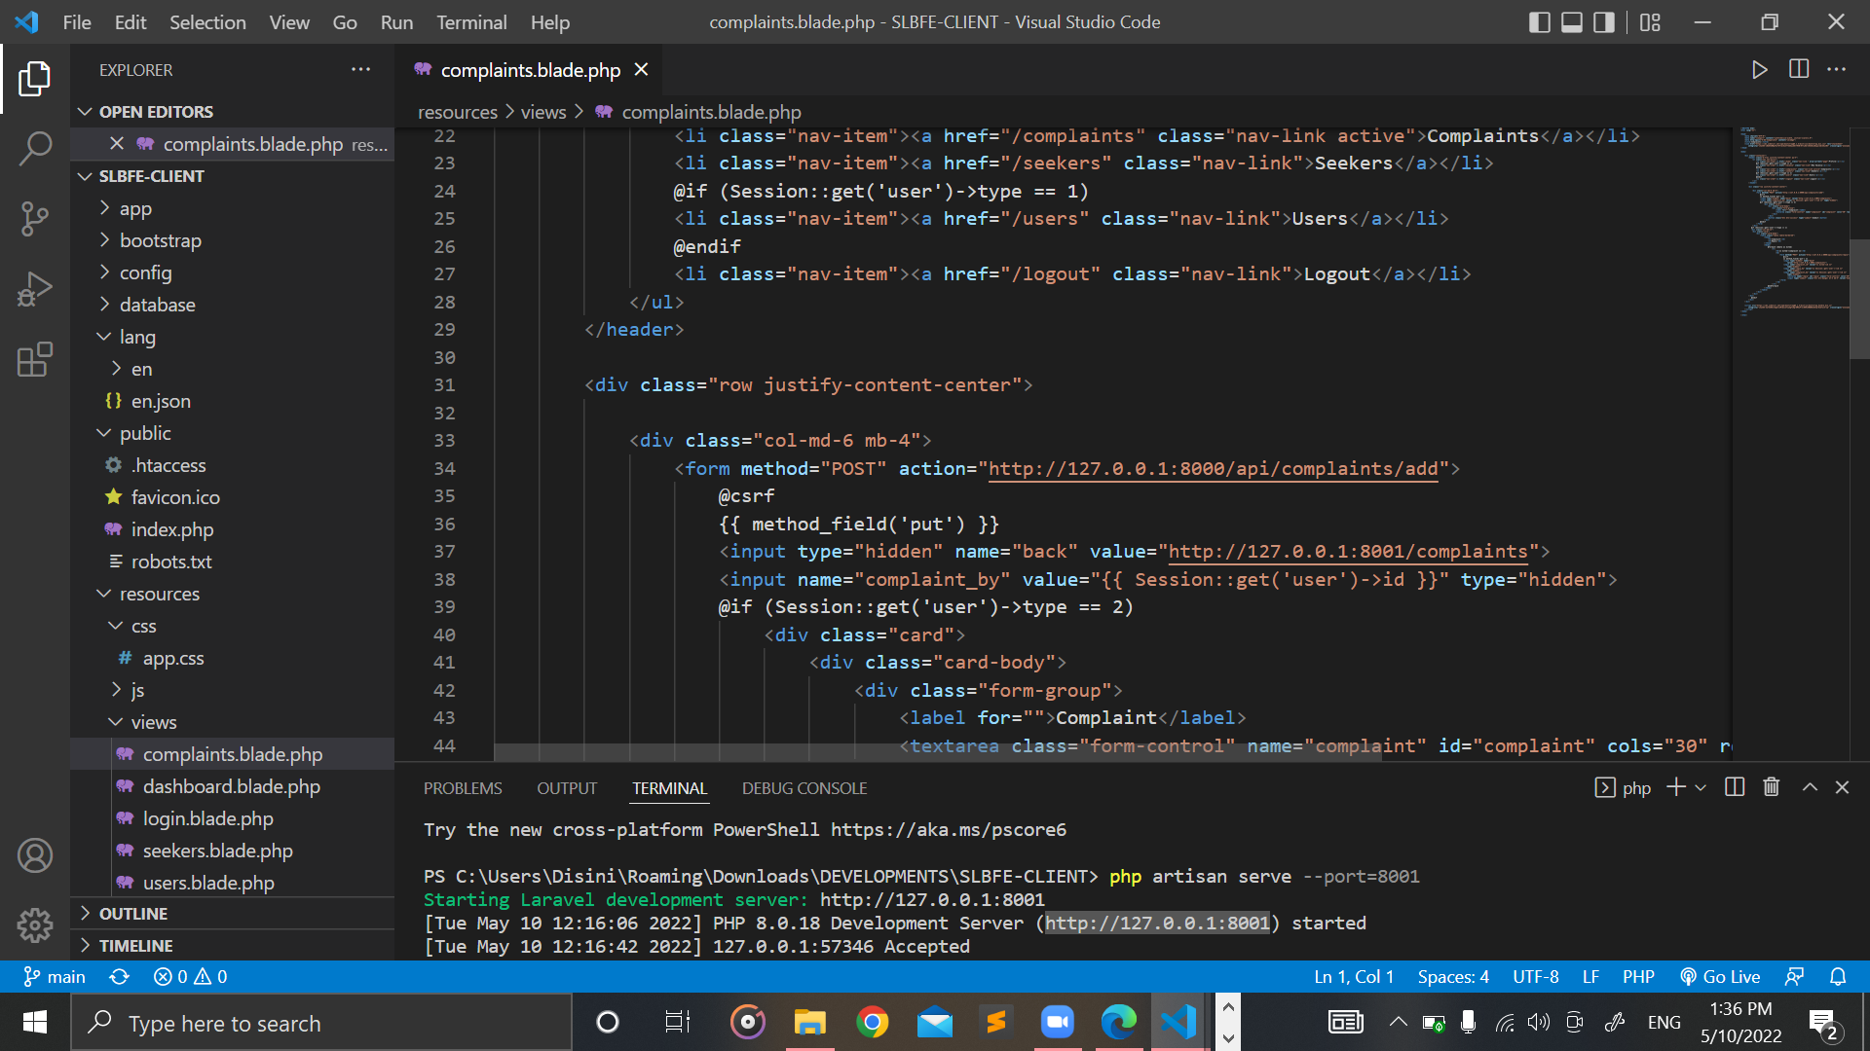

Figure 42: complaints.blade.php (Part 2)

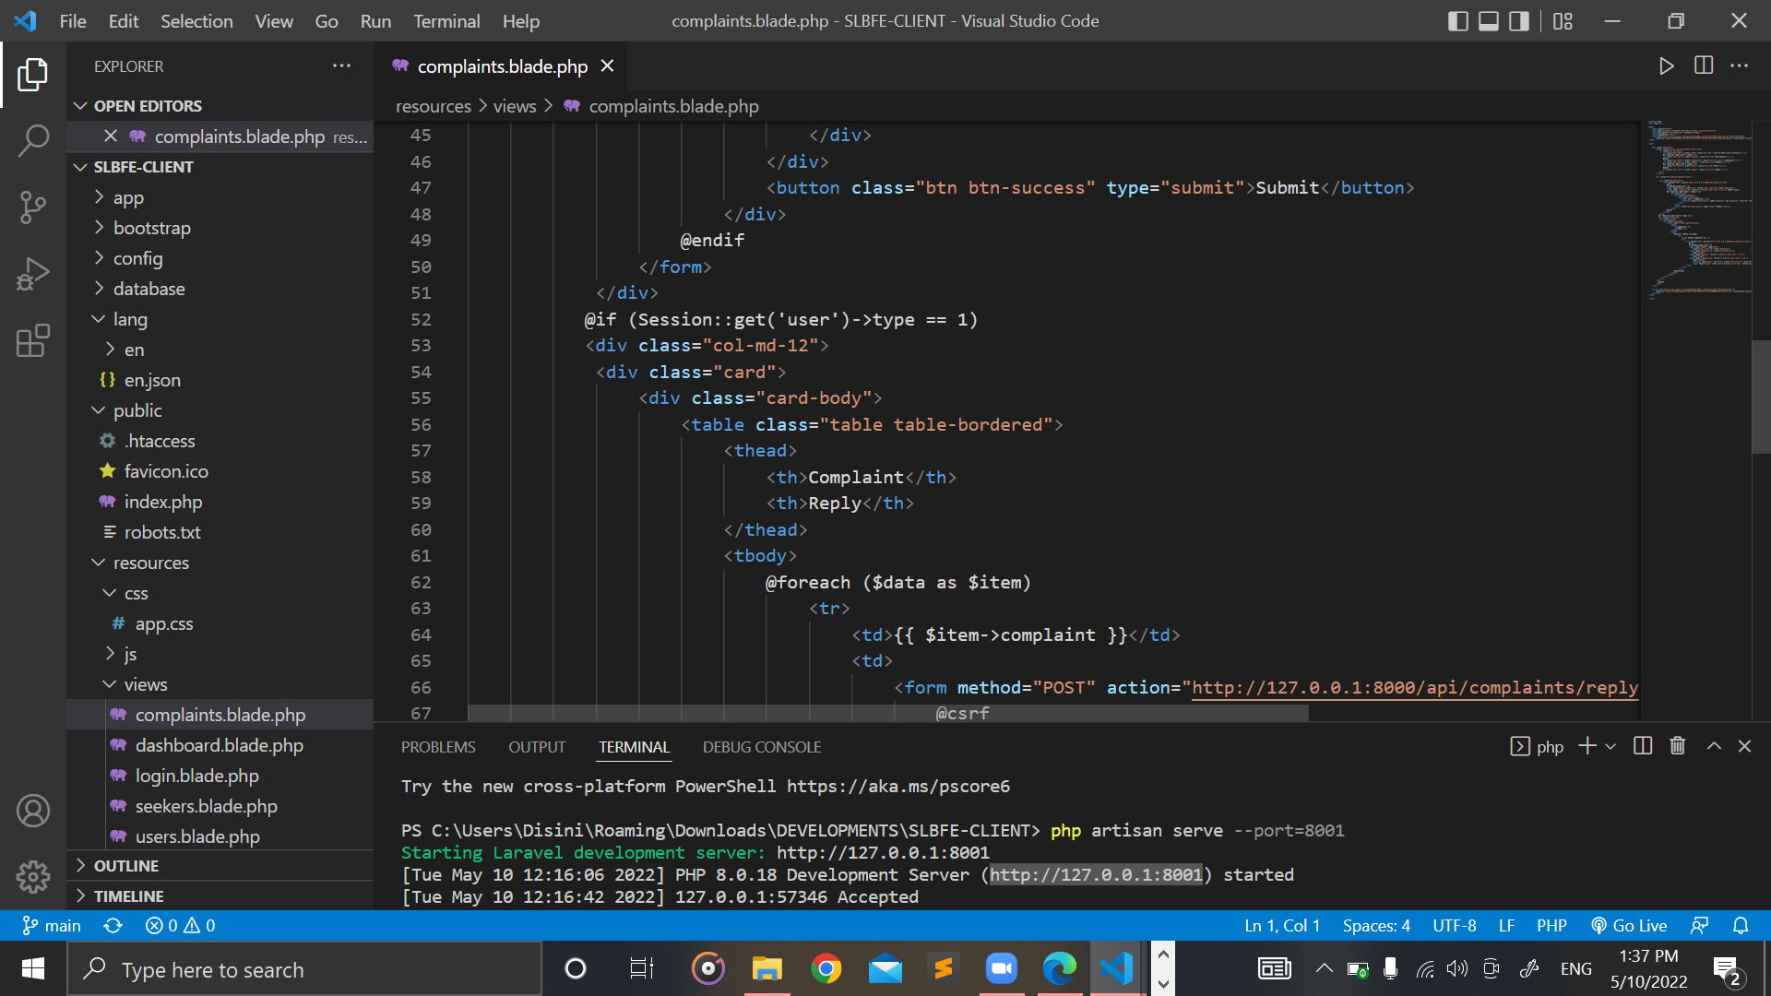

Figure 43: complaints.blade.php (Part 3)

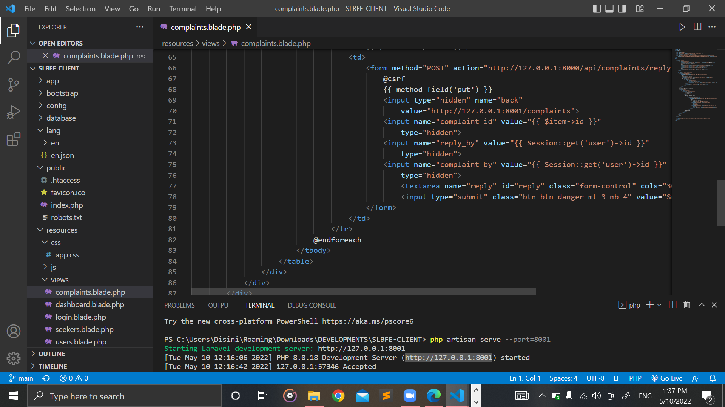

Figure 44: complaints.blade.php (Part 4)

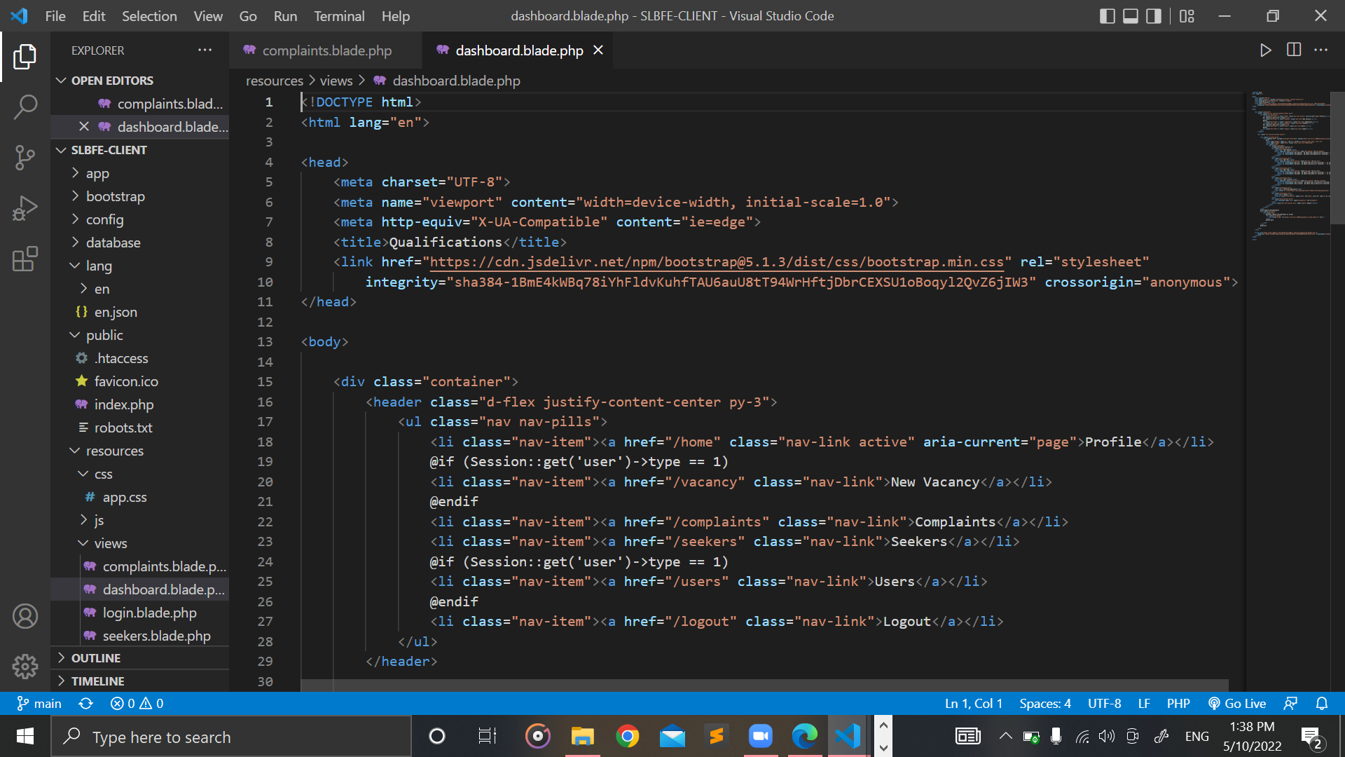

Figure 45: dashboard.blade.php

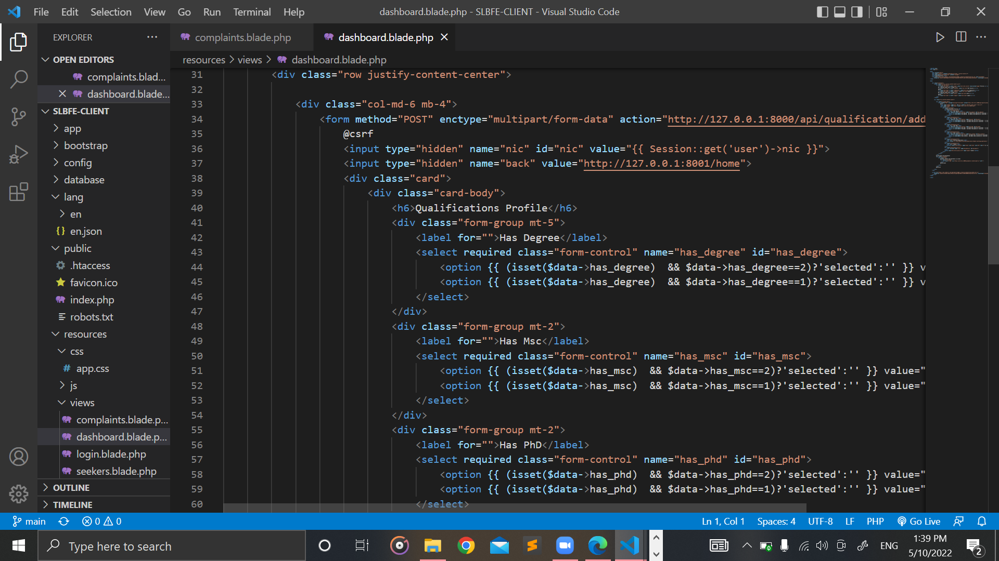

Figure 46: dashboard.blade.php (Part 2)

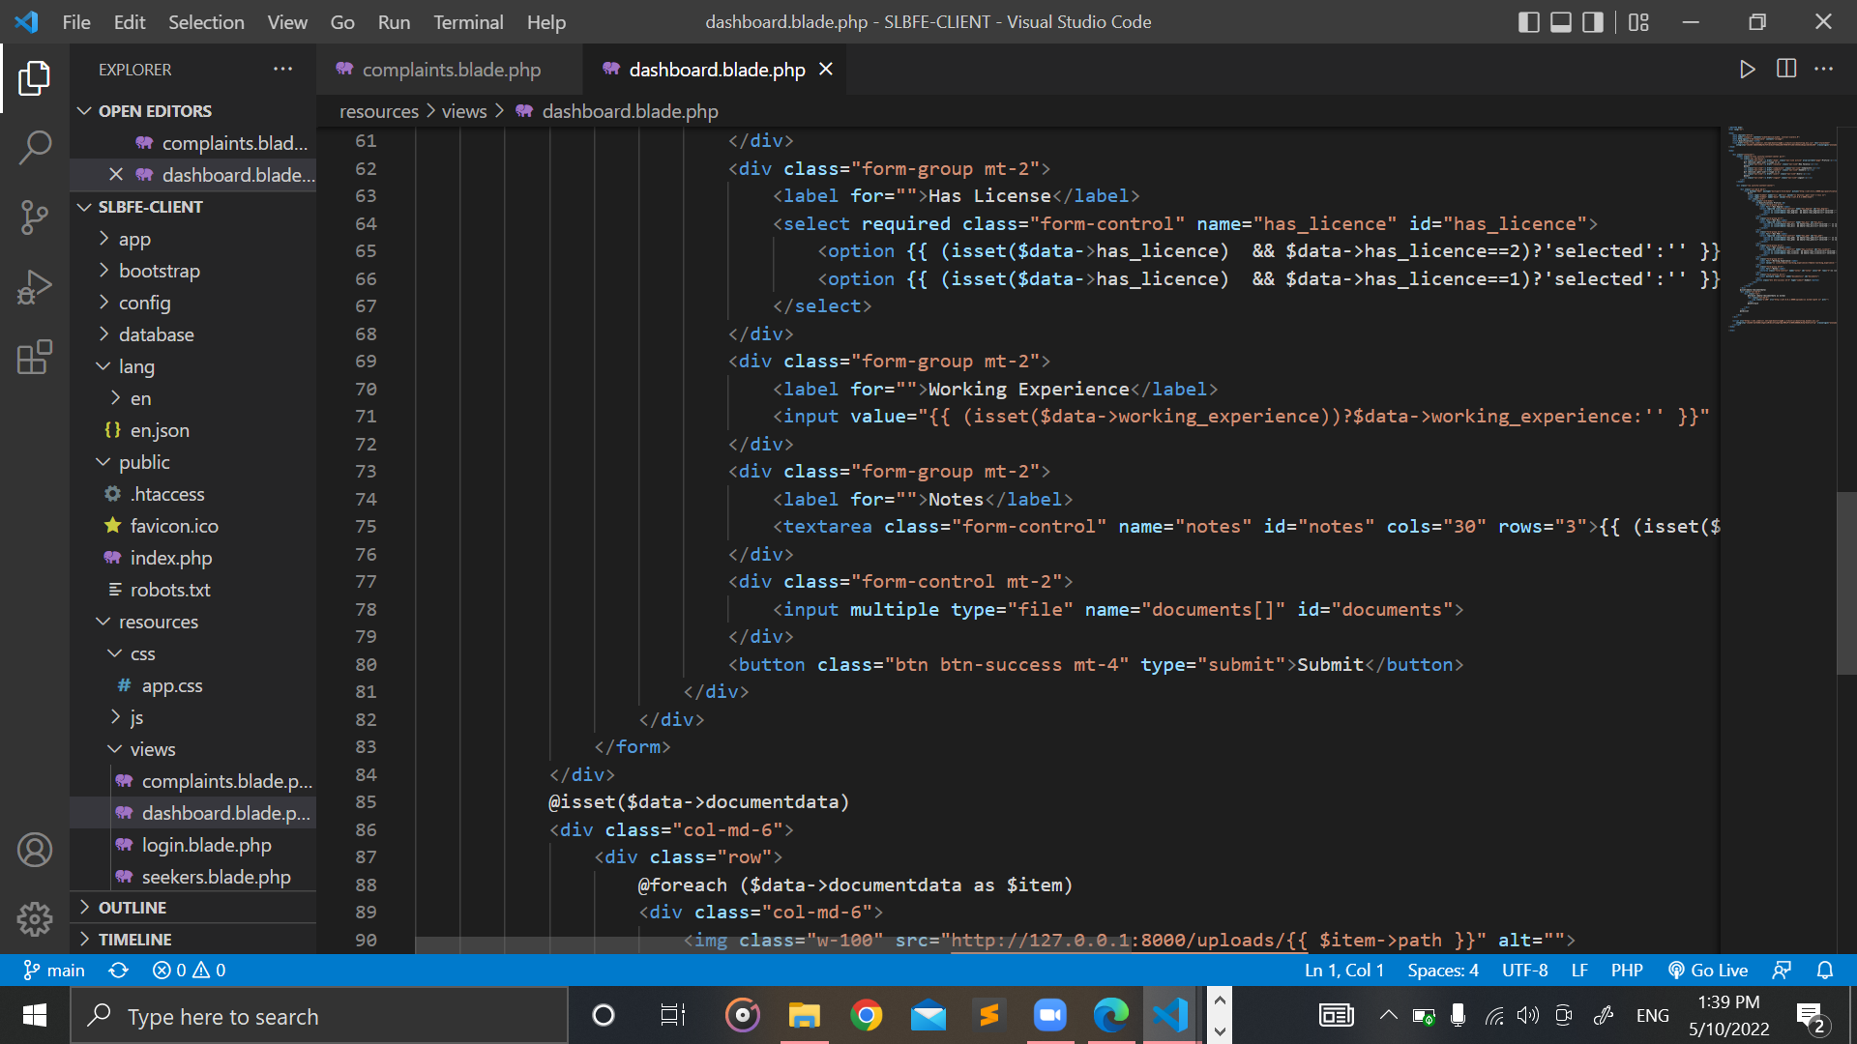

Figure 47: dashboard.blade.php (Part 3)

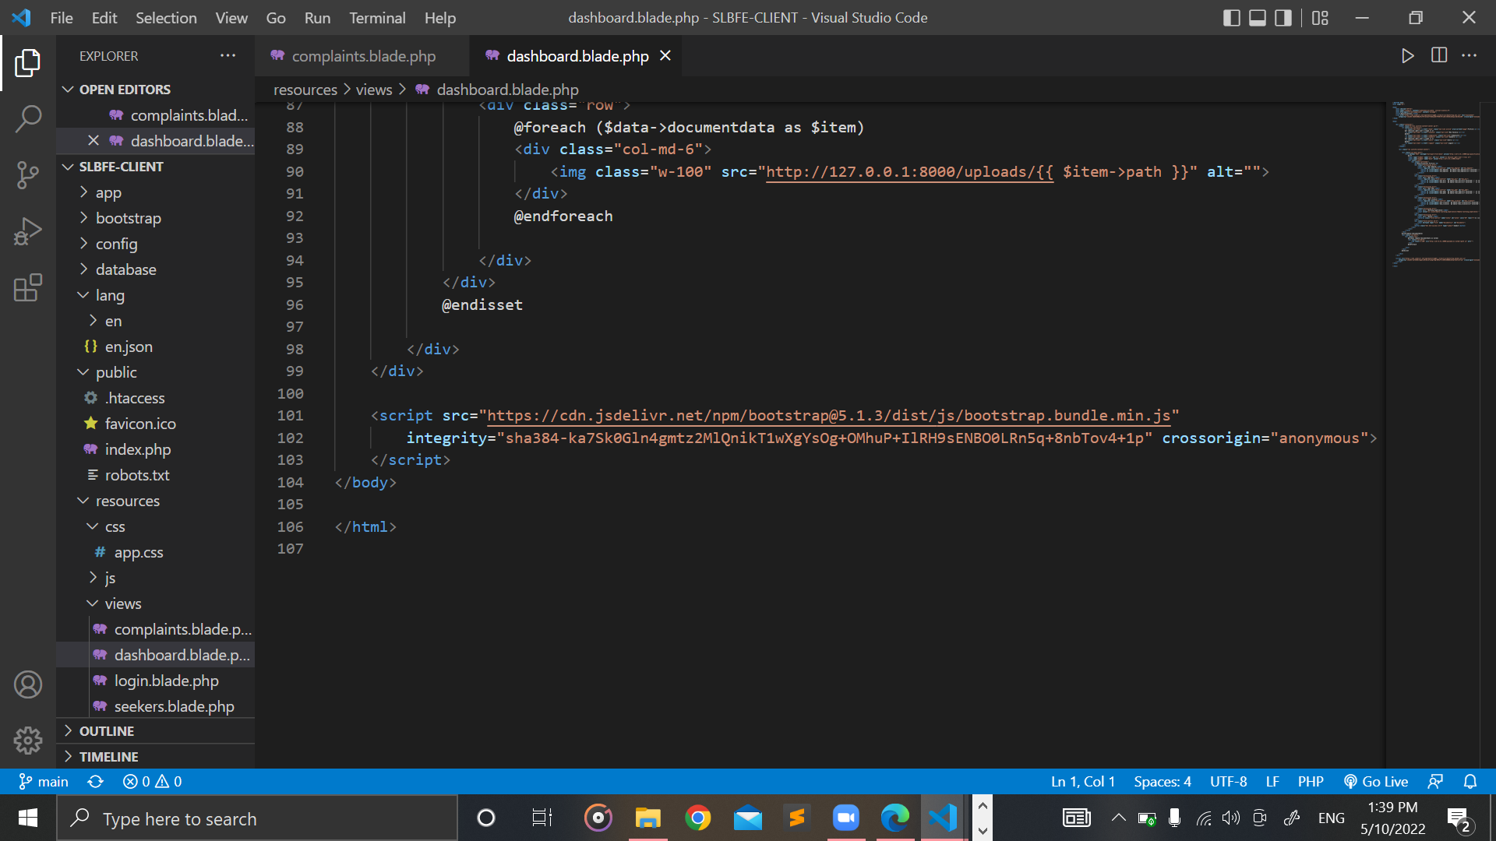

Figure 48: dashboard.blade.php (Part 4)

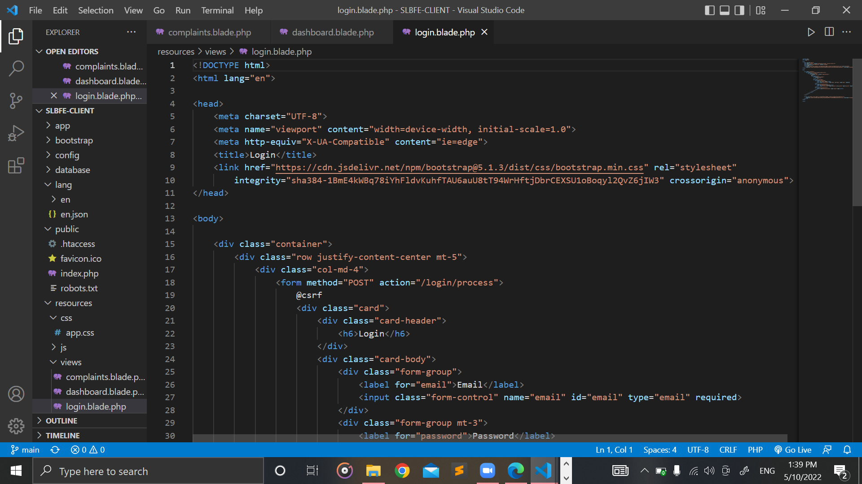

Figure 49: login.blade.php

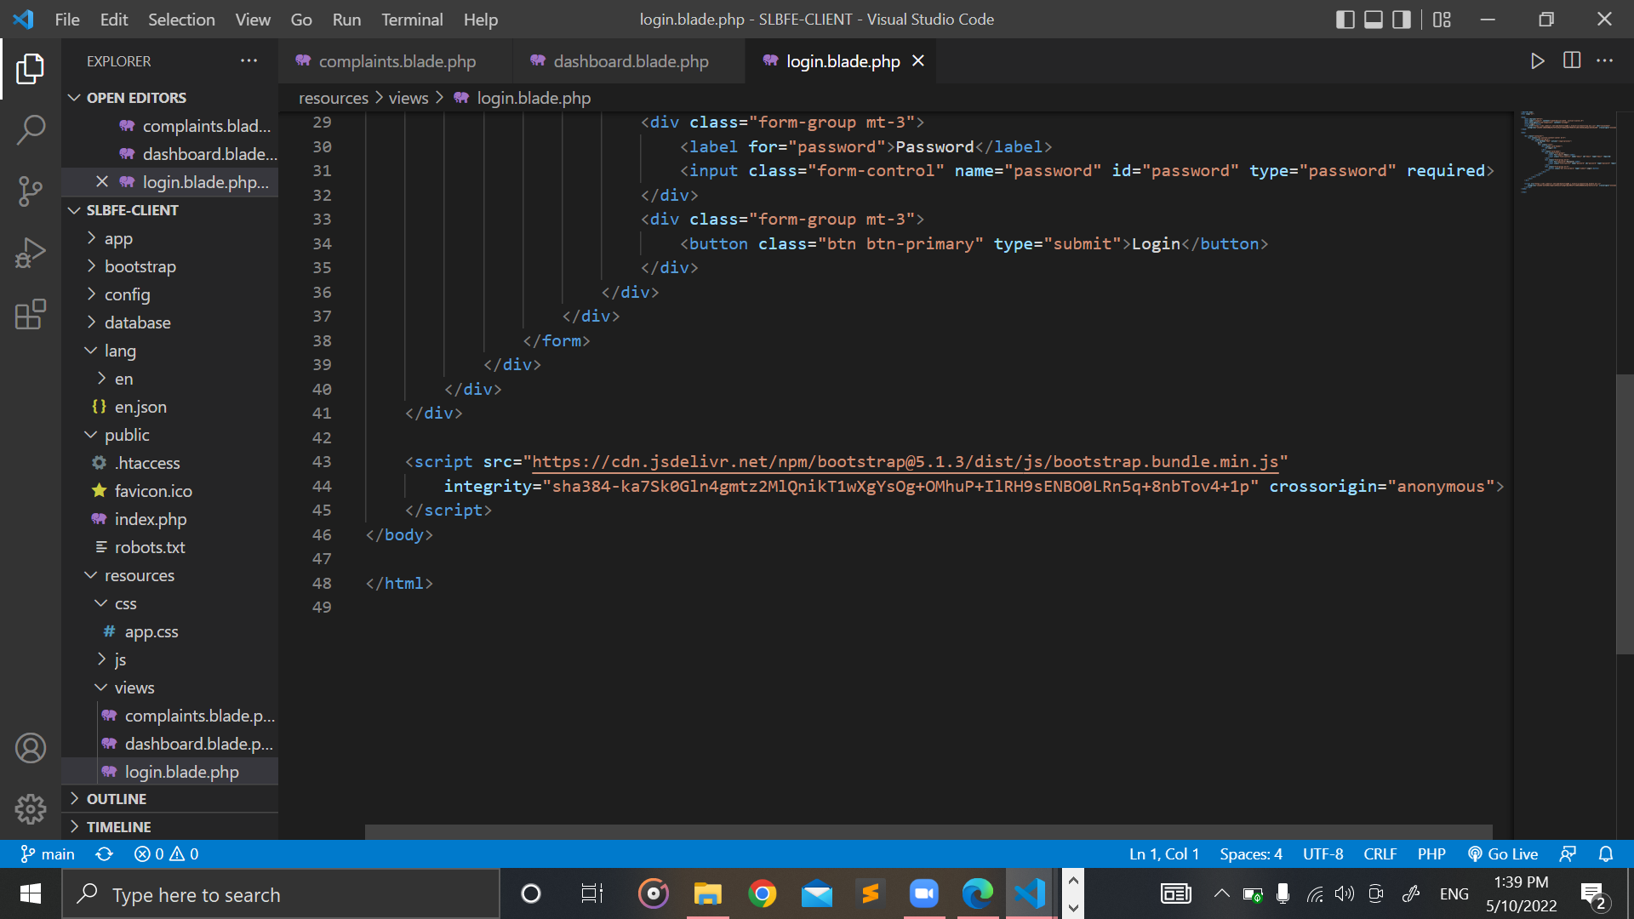

Figure 50: login.blade.php (Part 2)

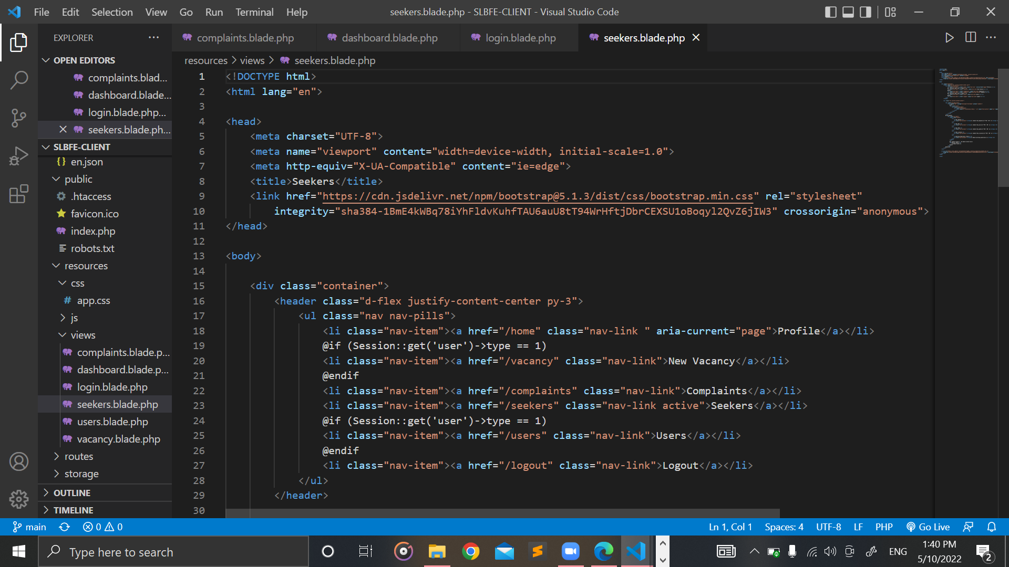

Figure 51: seekers.blade.php

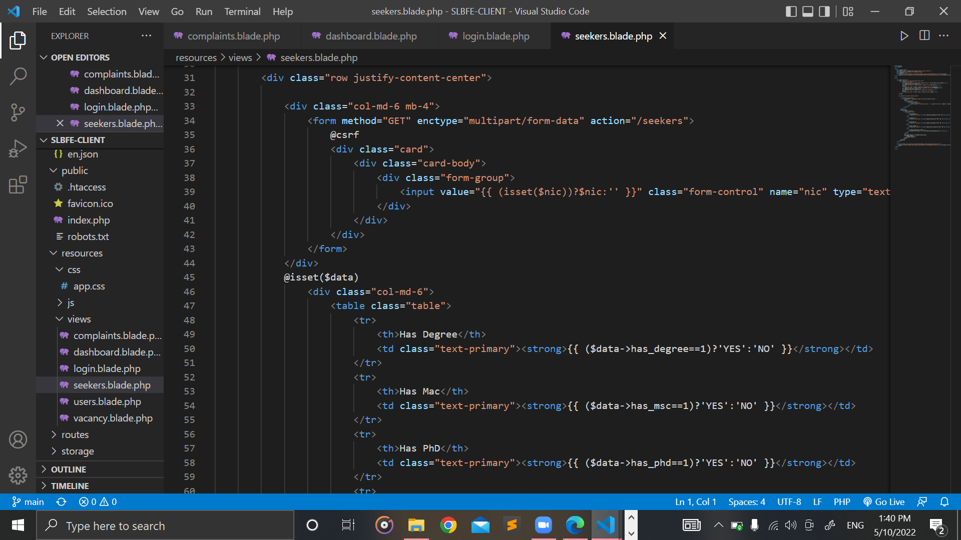

Figure 52: seekers.blade.php (Part 2)

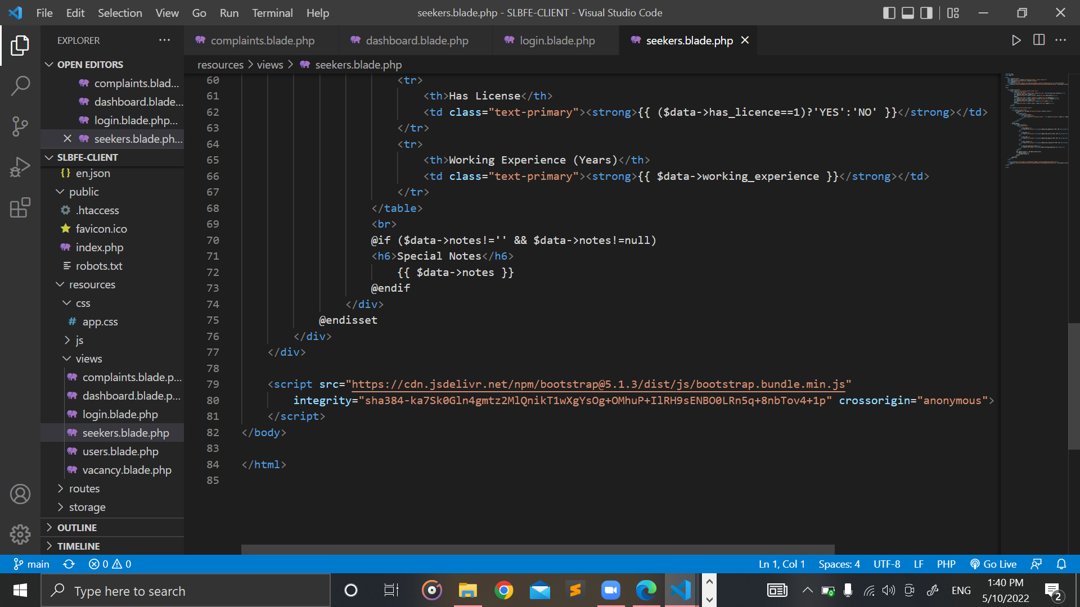

Figure 53: seekers.blade.php (Part 3)

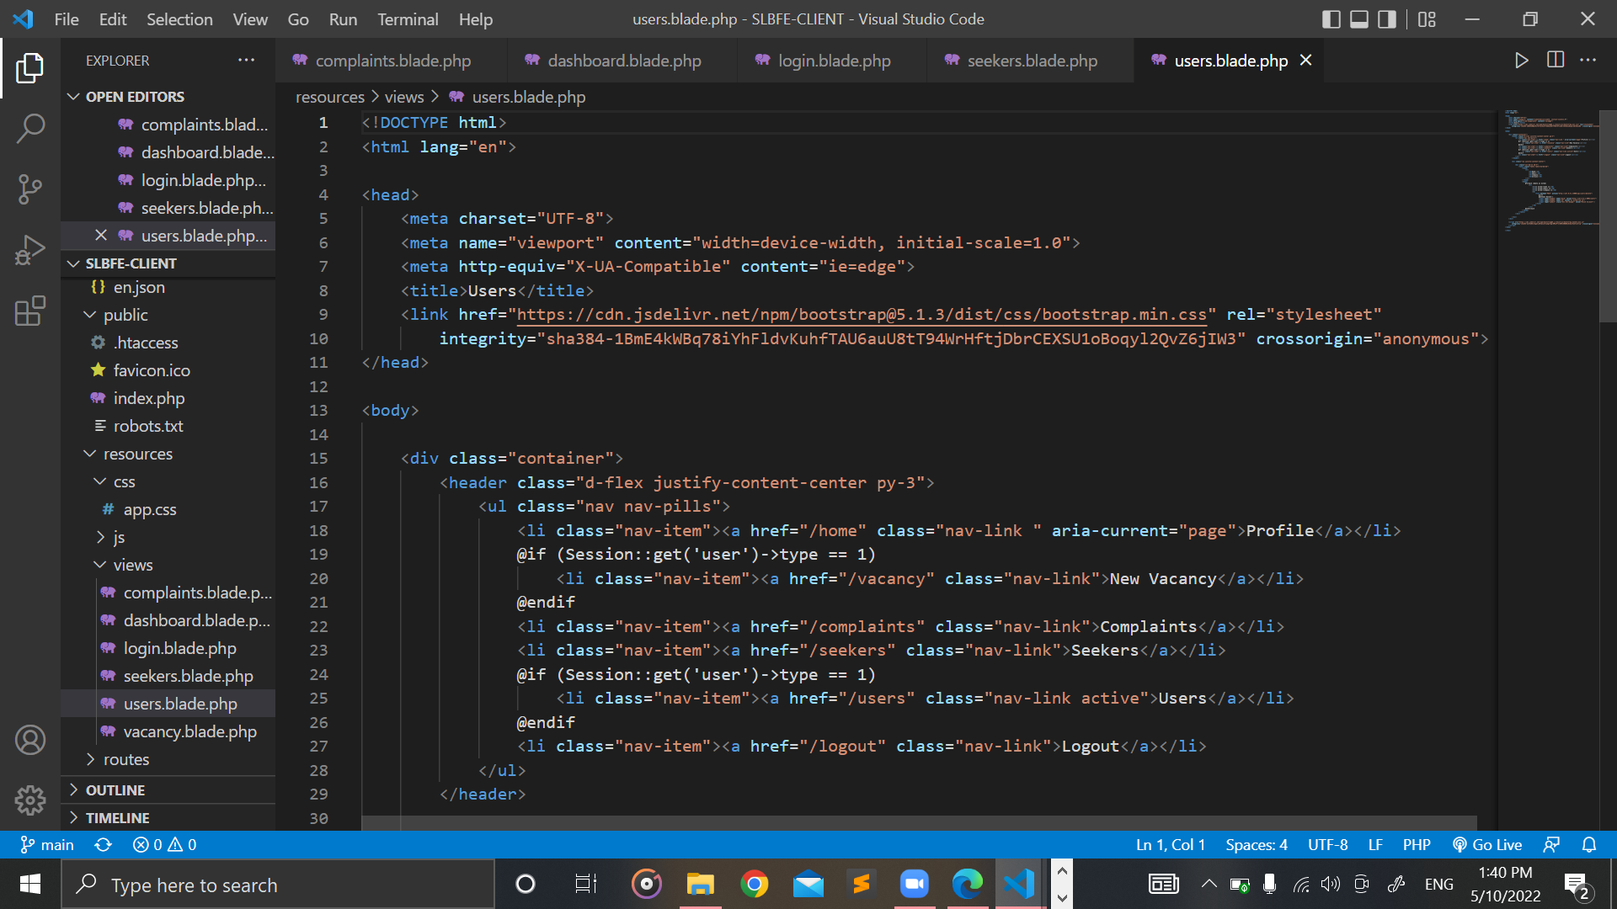

Figure 54: users.blade.php

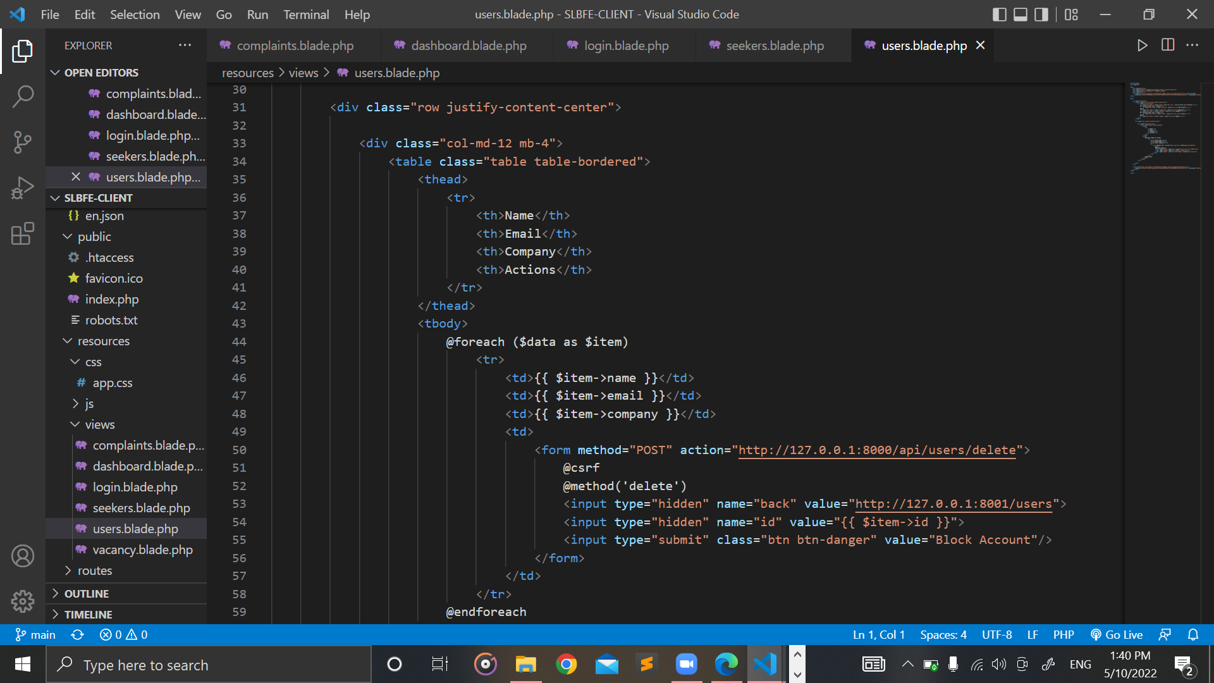

Figure 55: users.blade.php (Part 2)

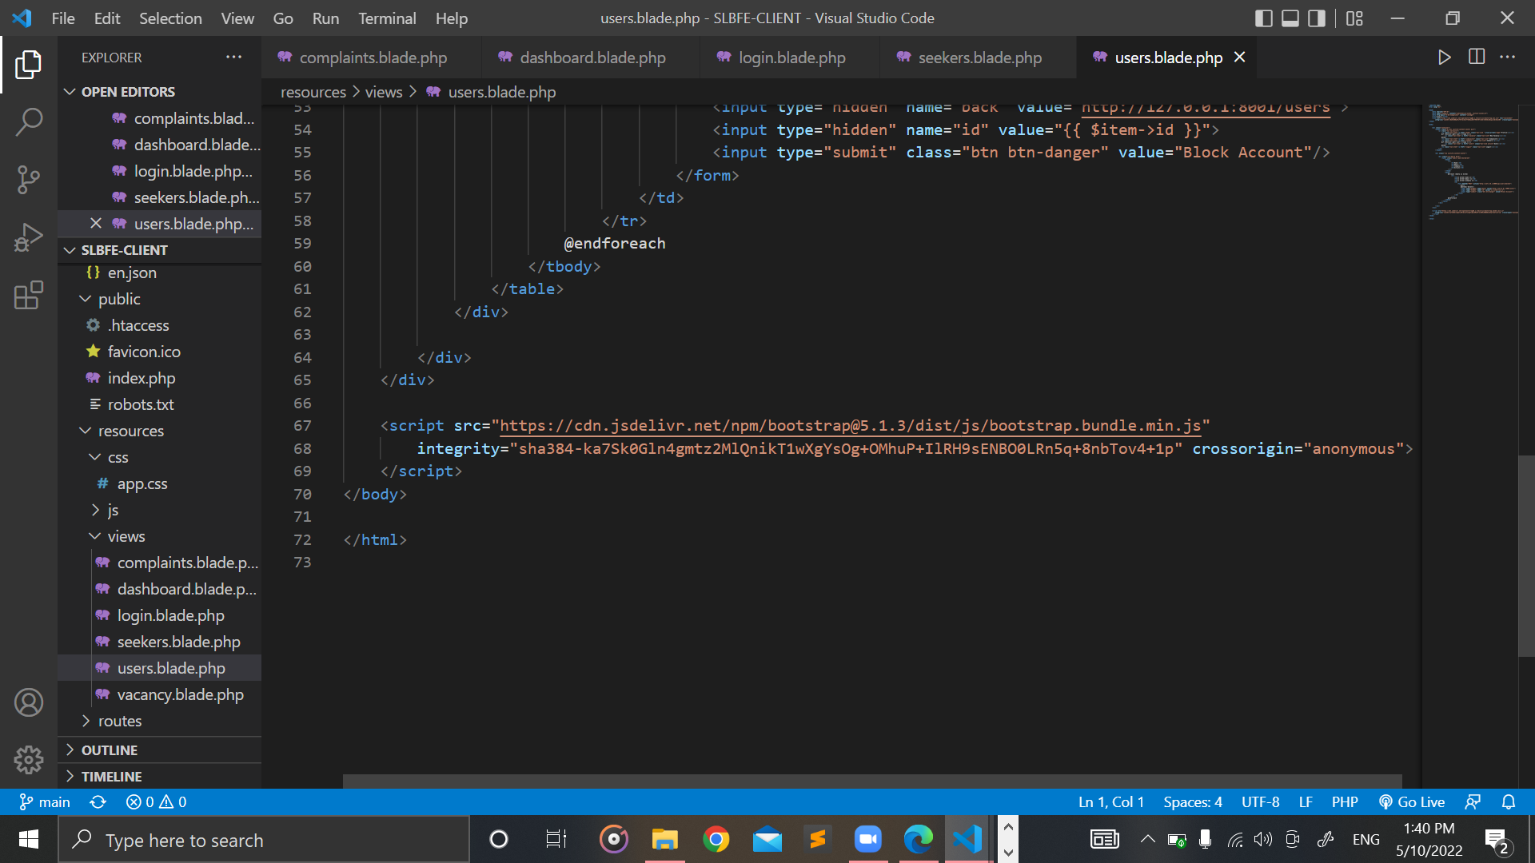

Figure 56: users.blade.php (Part 3)

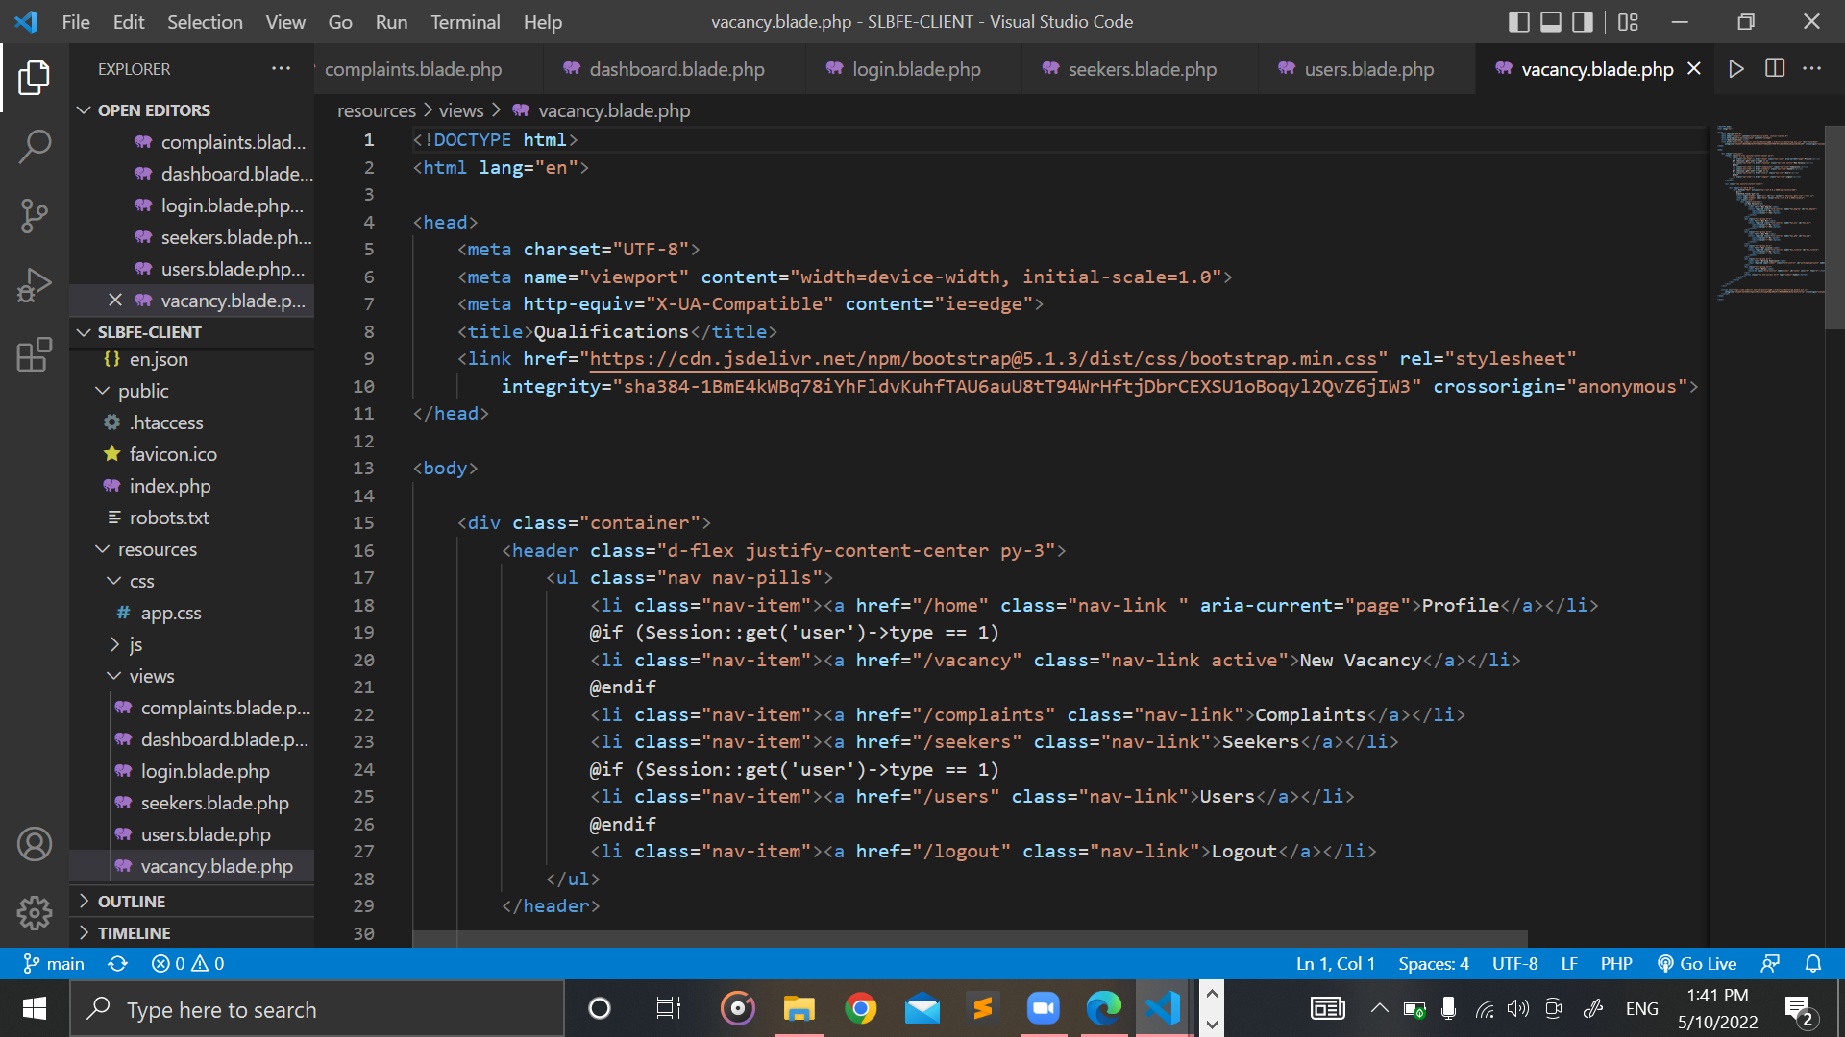

Figure 57: vacancy.blade.php

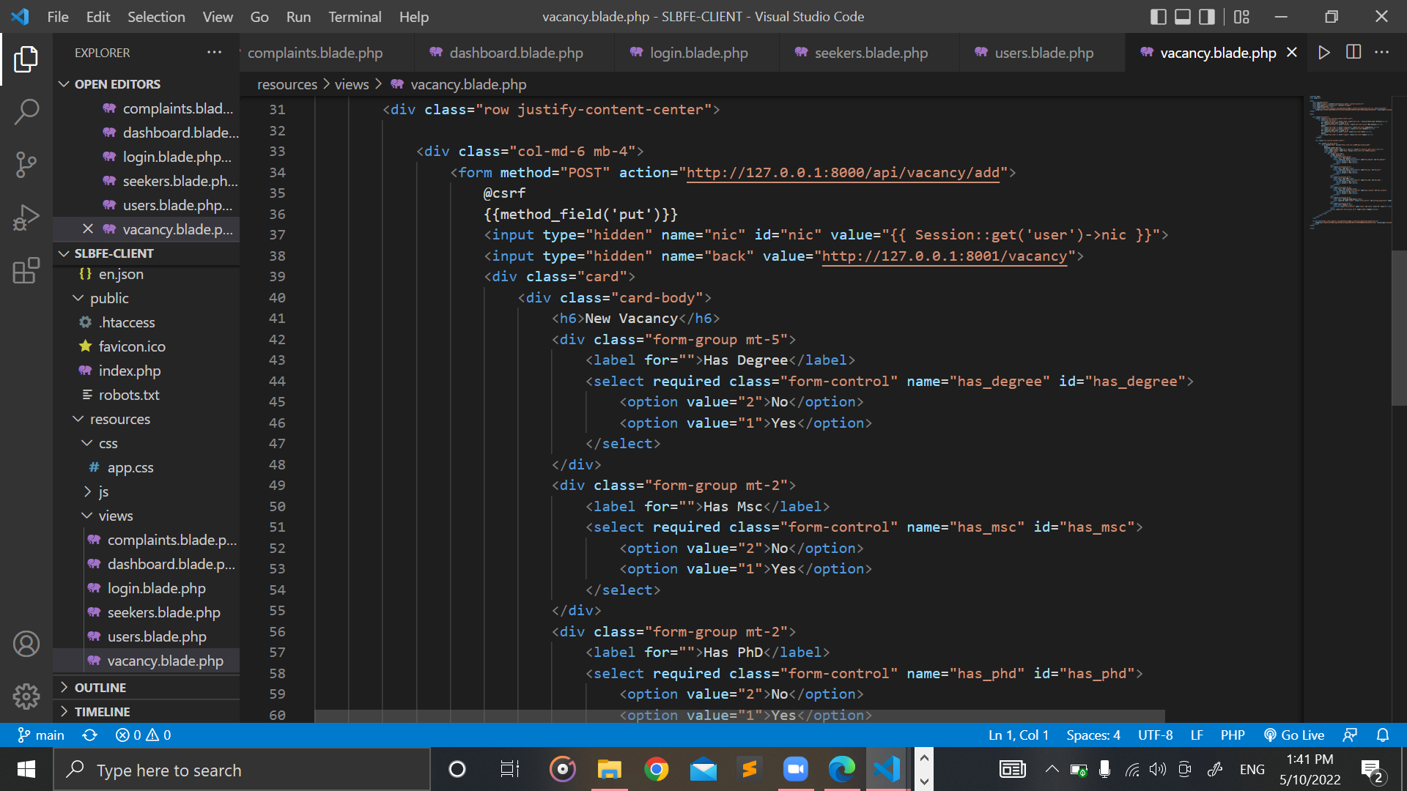

Figure 58: vacancy.blade.php (Part 2)

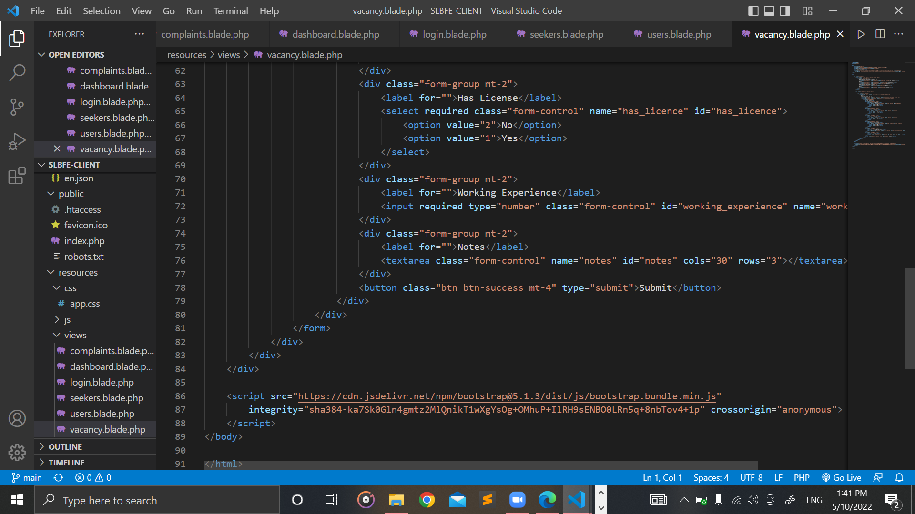

Figure 59: vacancy.blade.php (Part 3)

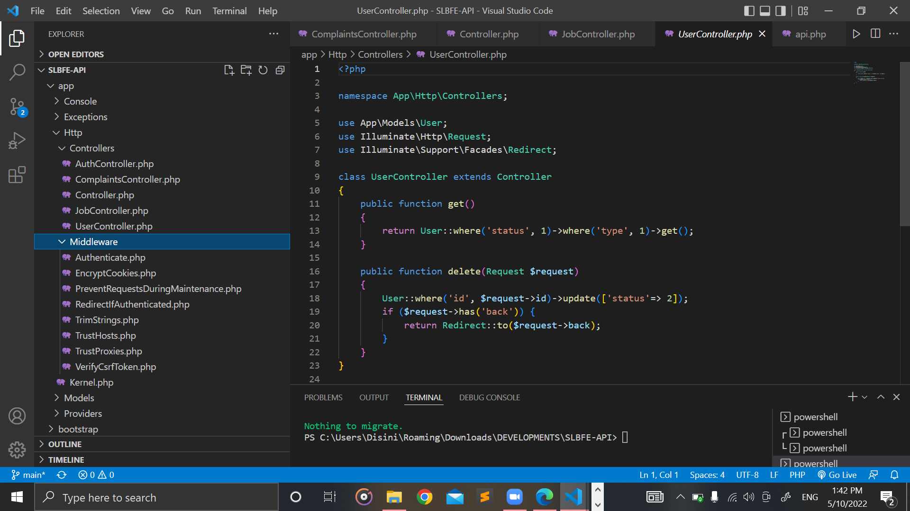

Figure 60: Middleware Folder

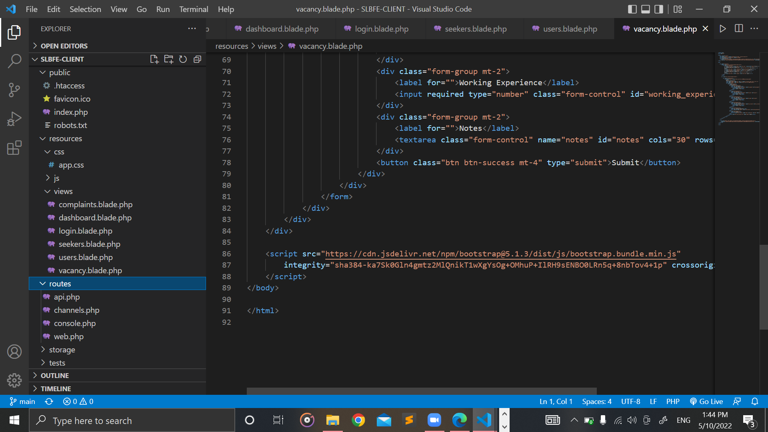

Figure 61: Routes Folder

## Screenshot of the Mobile Application Code

### Vacancy Adapter

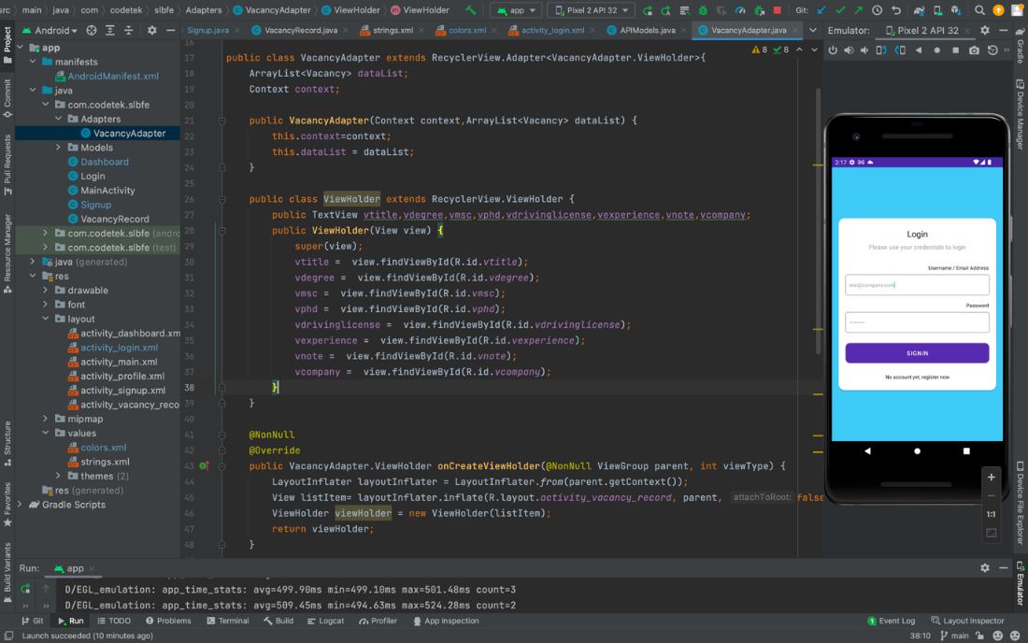

Figure 62: VacancyAdapter.java

### Dashboard

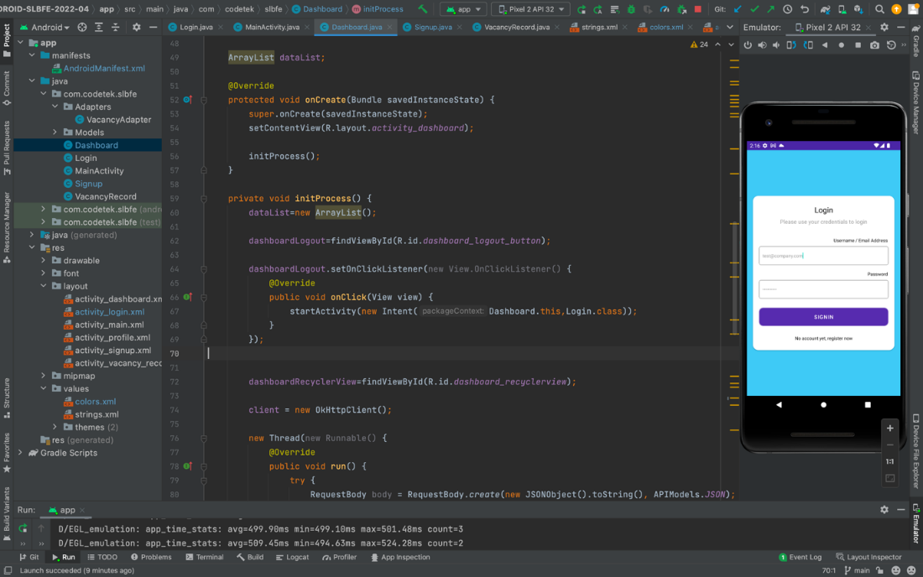

Figure 63: Dashboard.java

### Login

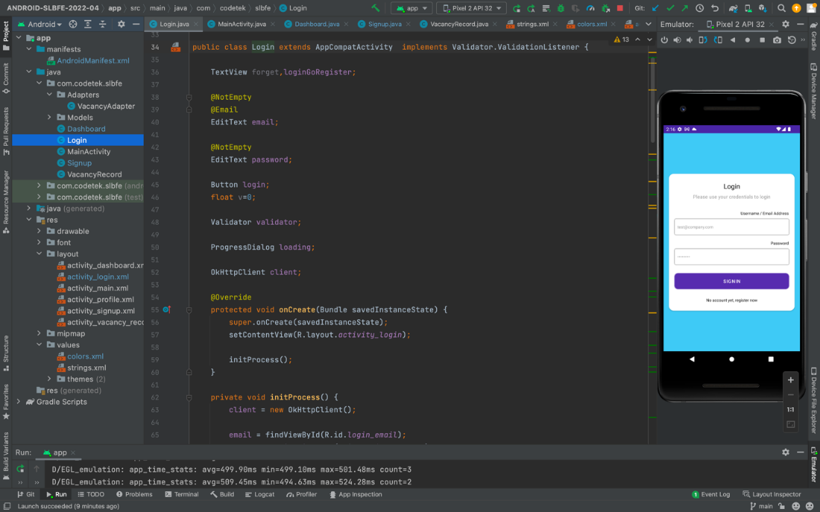

Figure 64: Login.java

### Main Activity

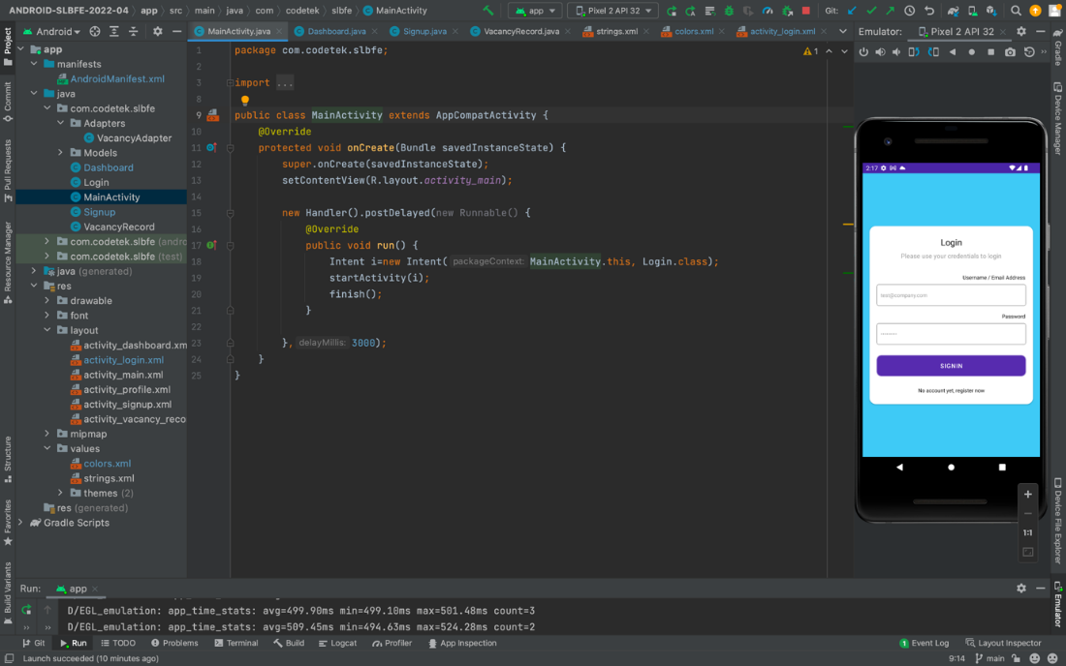

Figure 65: MainActivity.java

### Sign Up

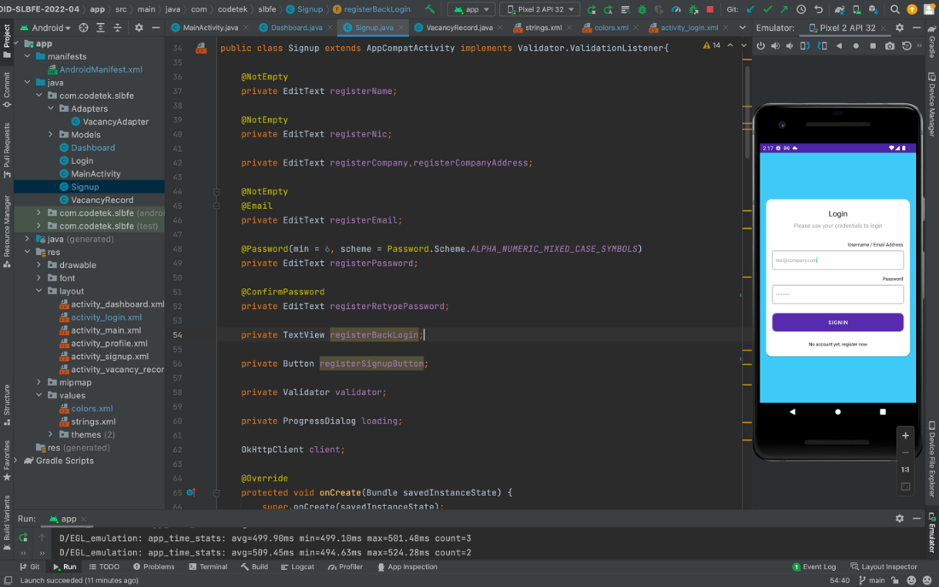

Figure 66: Signup.java

### Vacancy Record

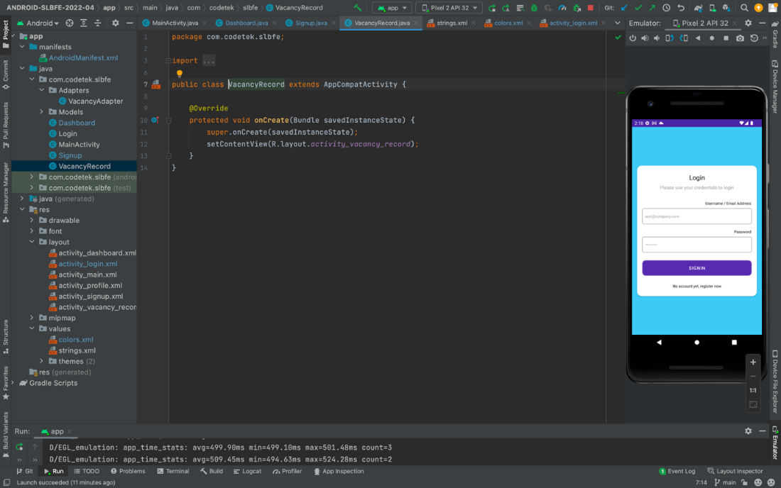

Figure 67: VacancyRecord.java

### Project Structure

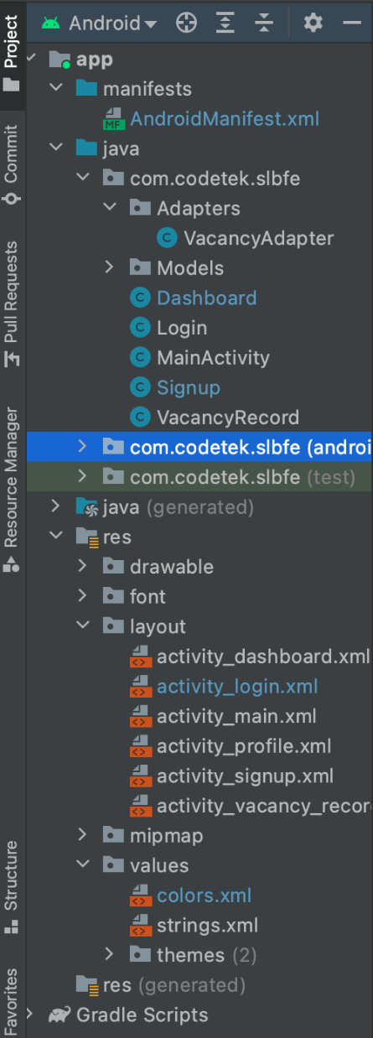

Figure 68: Project Structure

## Testing in POSTMAN

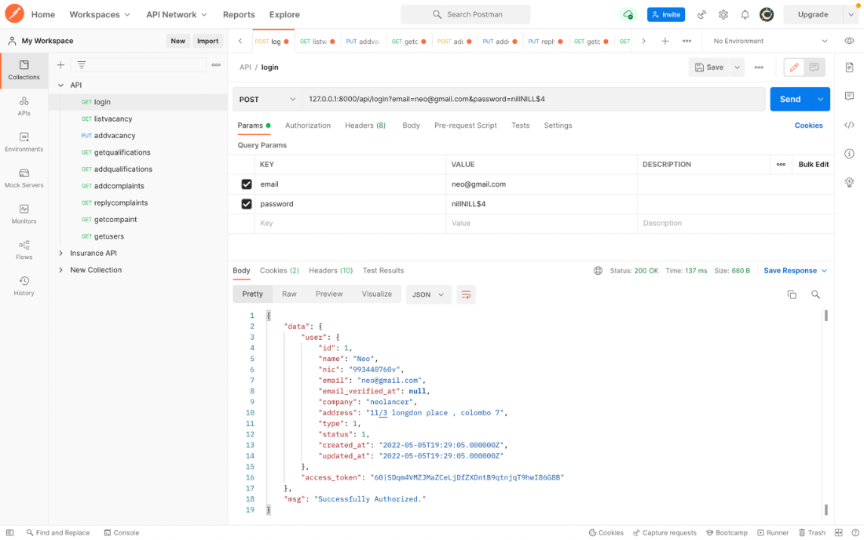

Figure 69: Login

All **POSTS** requests, as given in the above example, the endpoint identified as ‘login’ is separated using a ‘?’, the parameters are given under that is **email** and **password**. Upon saving a HTTP status message of “Successfully Authorized” (code:200) would be shown.

|  |  |  |
| --- | --- | --- |
| Field | Type | Description |
| National ID | String | Primary Key: ID of the citizen is created here. |
| Name | String | Citizen’s name formed under name. |
| Email | Email | Citizen’s Email formed under email. |
| Password | String | Citizen’s password formed under password. |
| Address | String | Citizen’s address formed under name. |
| Affiliation | String | Citizen’s affiliation formed under company. |

Table 1: Field's type and description

|  |  |
| --- | --- |
| Error Code | Description |
| 401 | Invalid Data / Unauthorized. |
| 200 | Successfully registered. |

Table 2: Potential Failure Responses

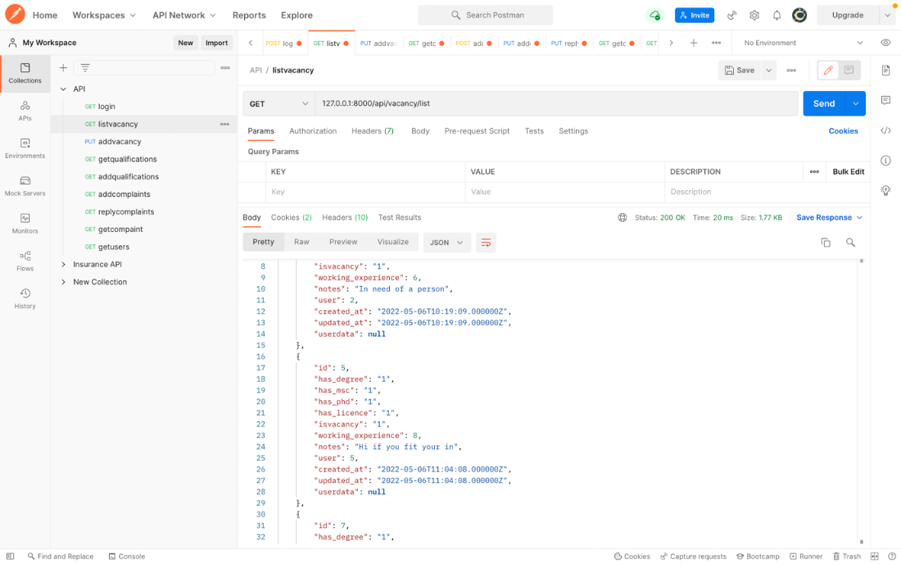

Figure 70: List Vacancy

The GET is used to retrieve data, an example of the screenshots when retrieving all data.

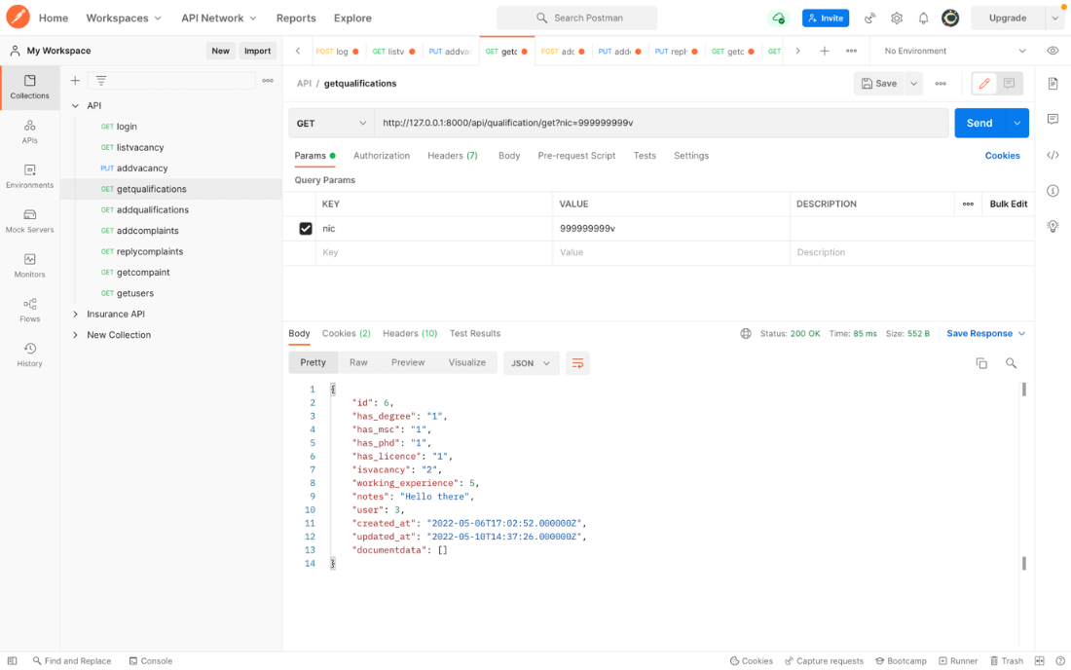

Figure 71: Get Qualification

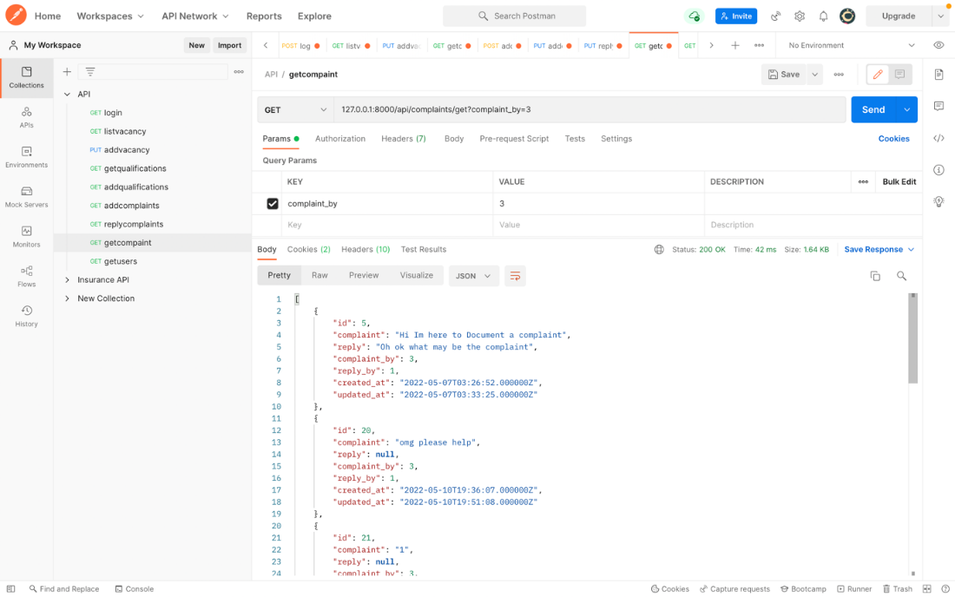

Figure 72: Get Complains

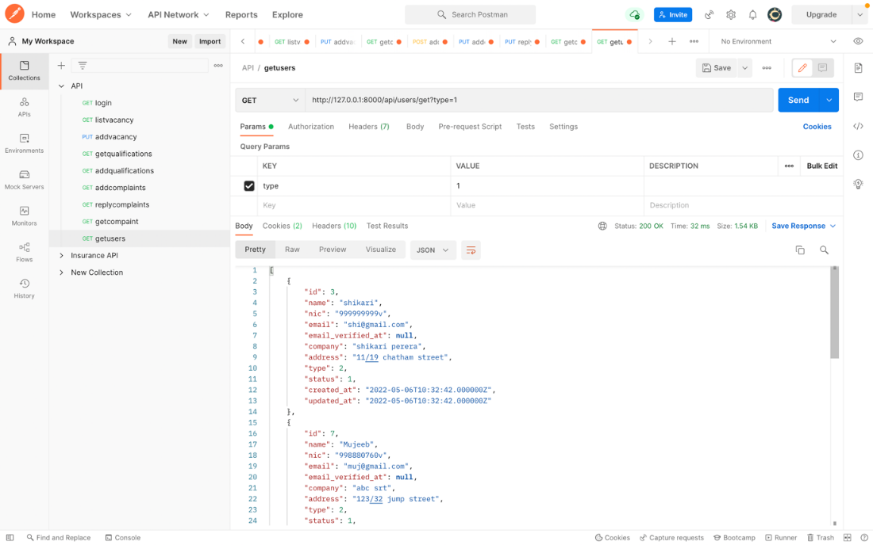

Figure 73: Get Users

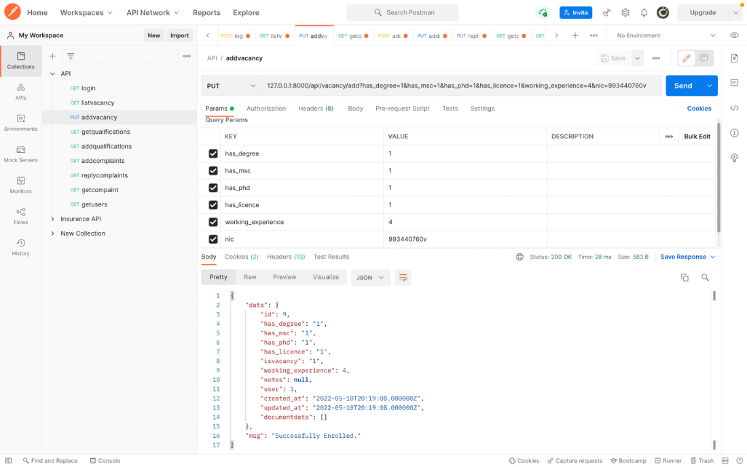

Figure 74: Add Vacancy

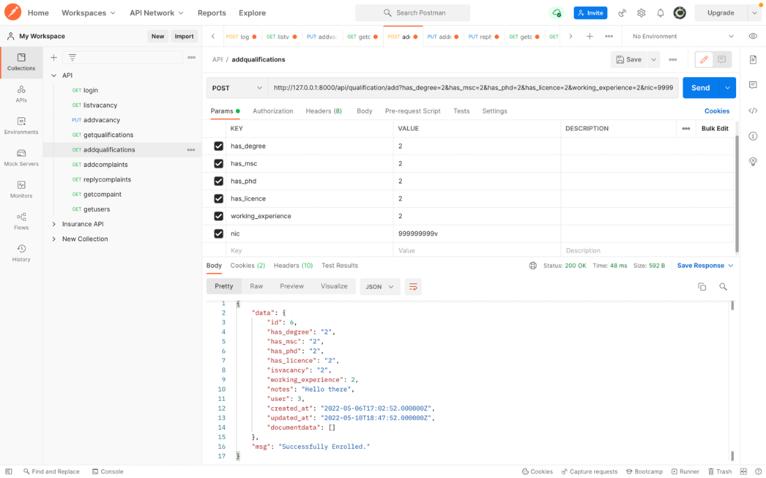

Figure 75: Add Qualification

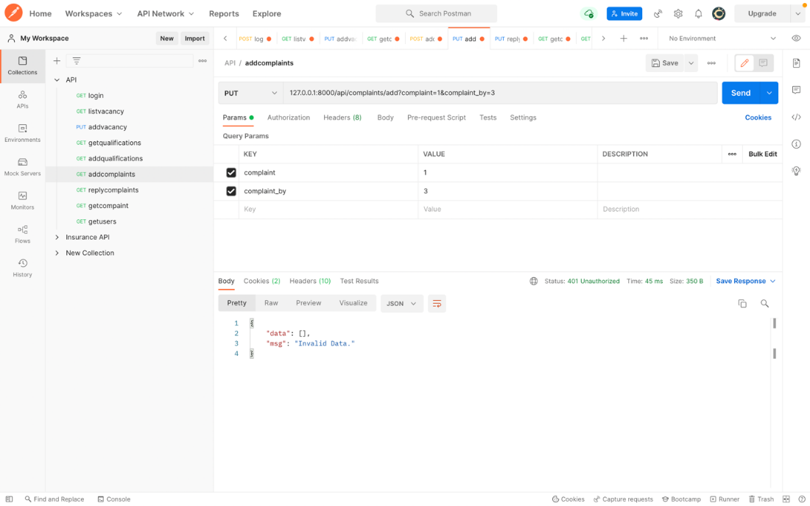

Figure 76: Add Complains

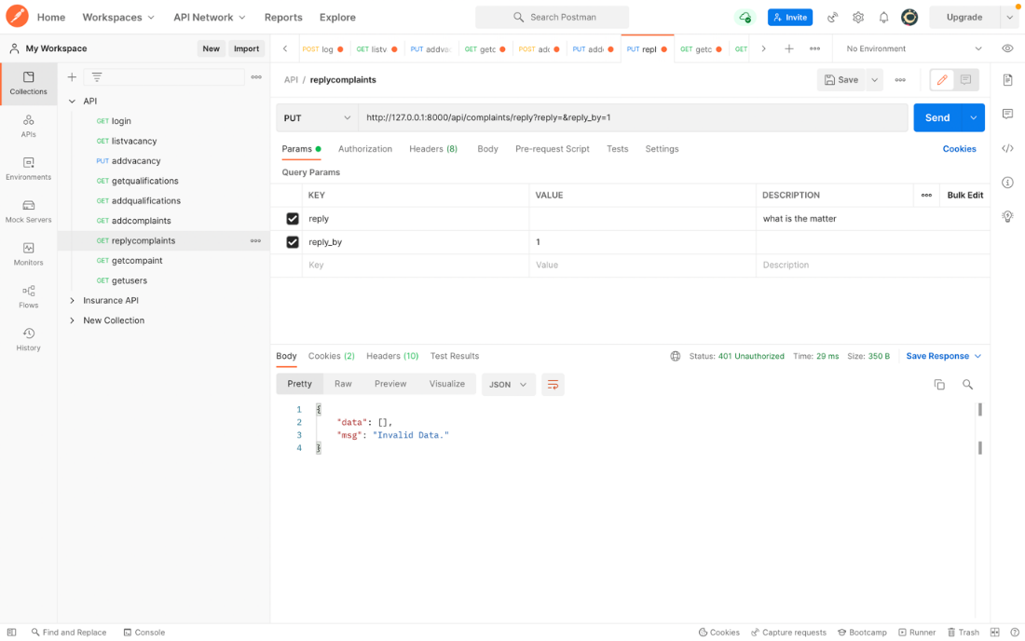

Figure 77: Reply Complains

## XML

The rest that follows are the samples of the XML format.

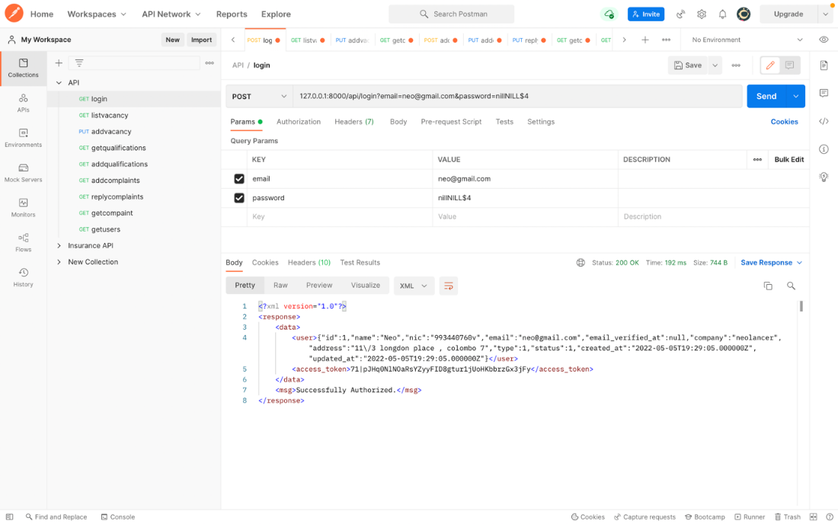

Figure 78: Login XML Code

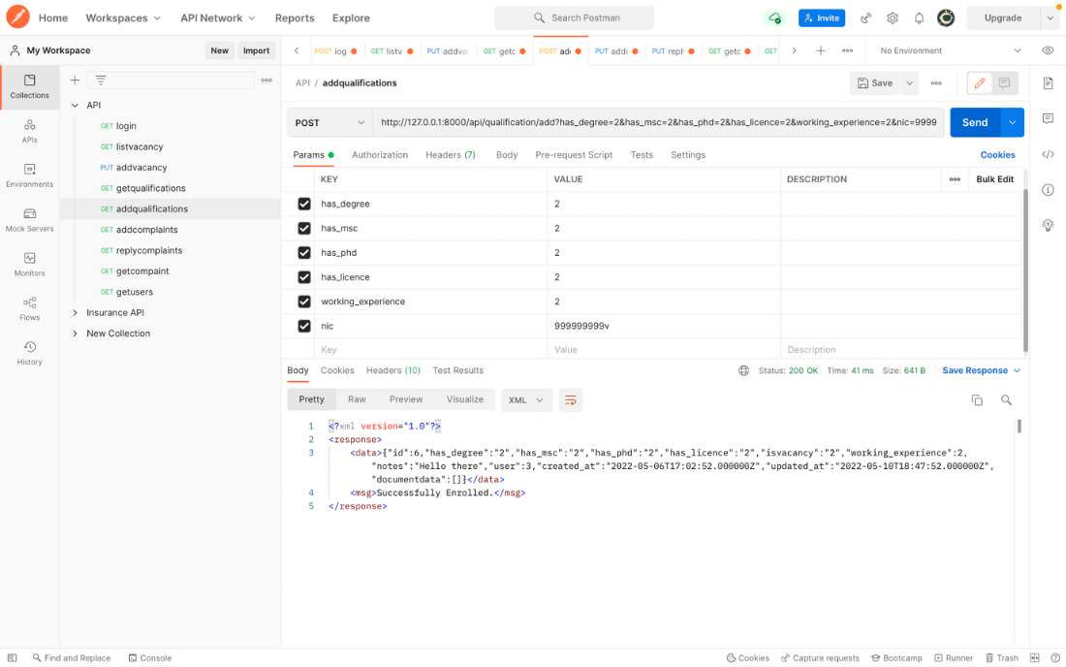

Figure 79: Add Qualifications XML Code

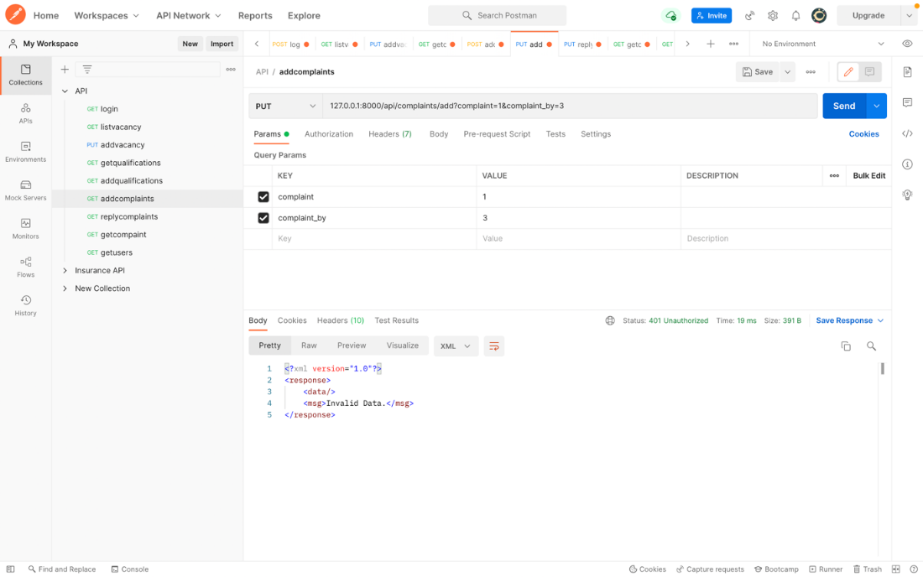

Figure 80: Add Complains XML Code

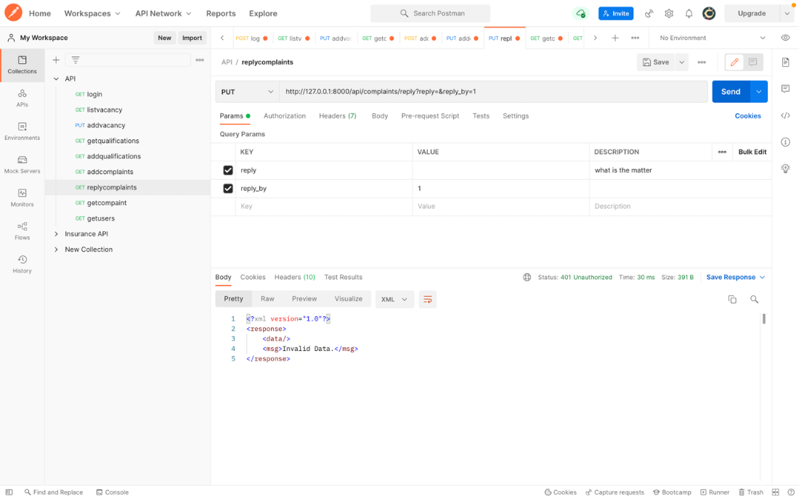

Figure 81: Reply Complaints XML Code

# Individual Contributions

## N. S. D. Alwis (10707160)

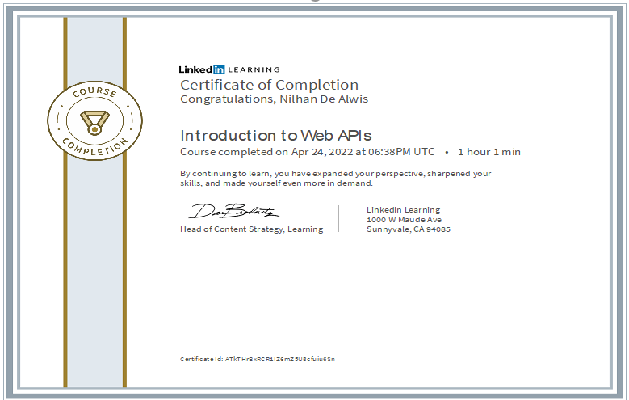

## G. M. D. D. Rathnayake (10707351)

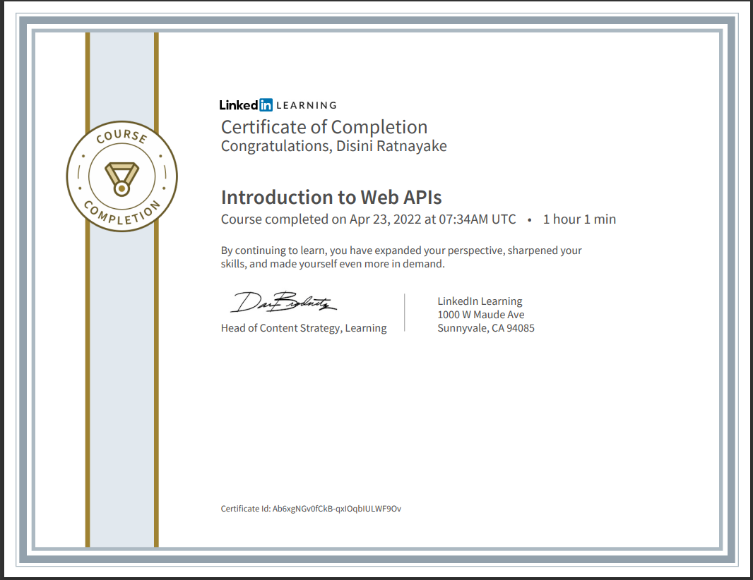

## S. O. Perera (10707315)

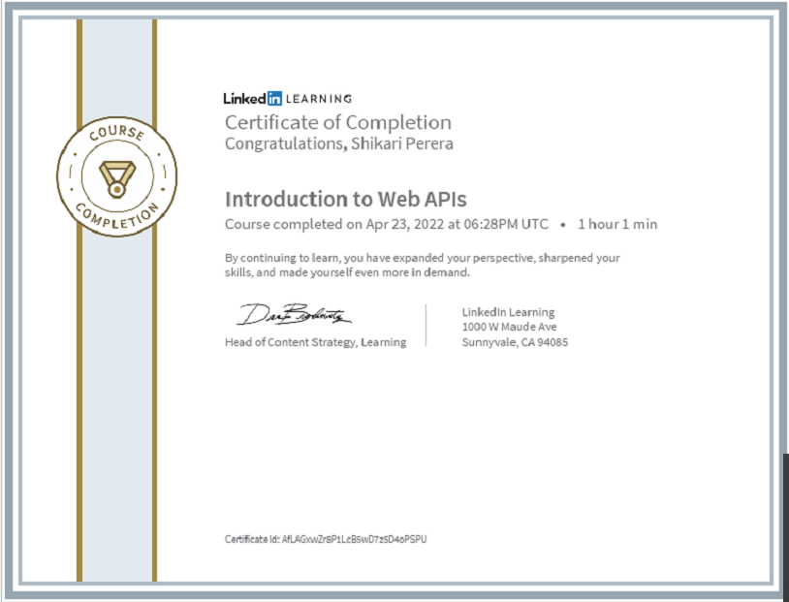

## P. P. L. Dilhani (10709402)

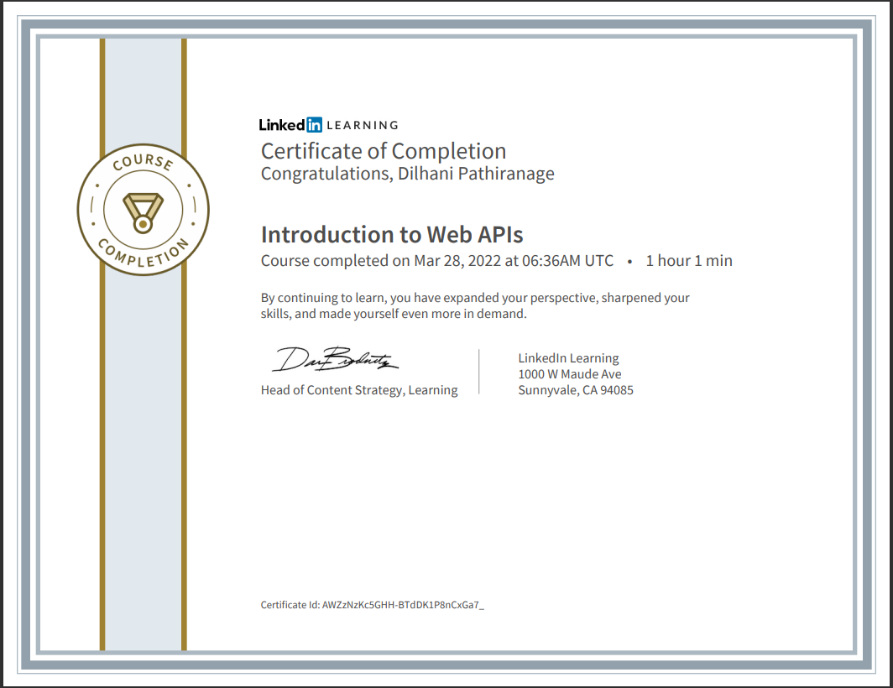

## J.A. Mujeeb (10707284)

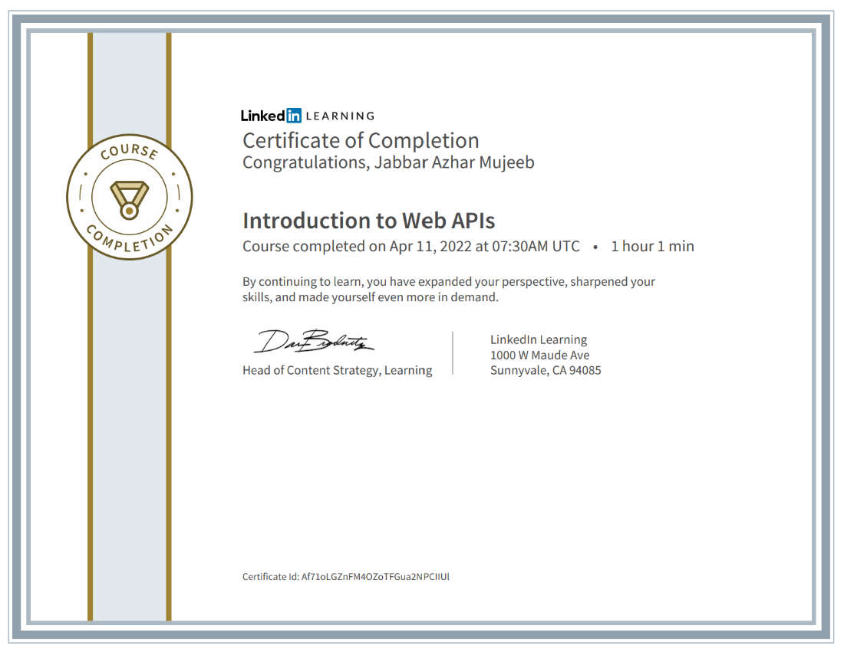

## M. D. A. Medhavi (10707278)

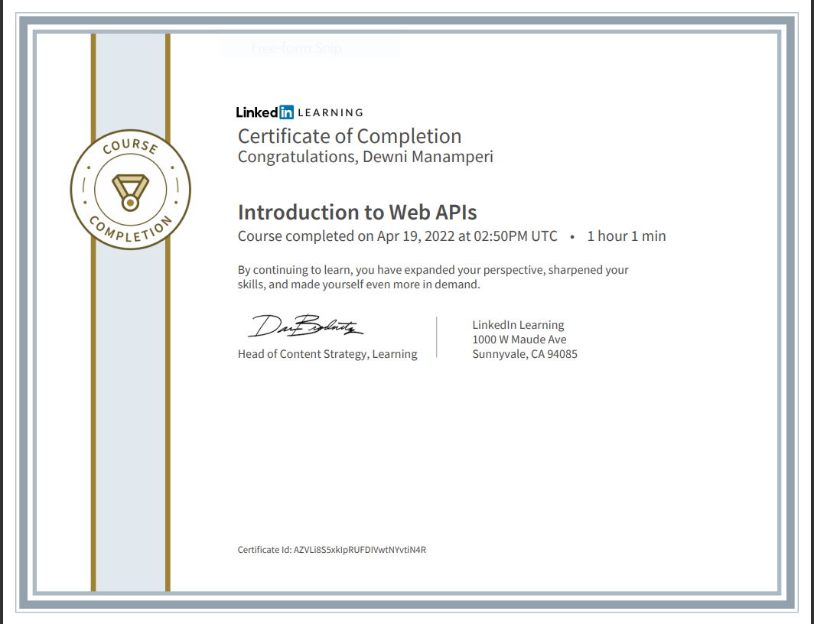

# Team Contribution

|  |  |  |
| --- | --- | --- |
| **Name** | **Student ID** | **Contribution** |
| J.A. Mujeeb | 10707284 | 16.7% |
| G.M.D.D. Ratnayake | 10707351 | 16.7% |
| S.O. Perera | 10707315 | 16.7% |
| N. S. De Alwis | 10707160 | 16.7% |
| M. D. A. Medhavi | 10707278 | 16.7% |
| P. P. L. Dilhani | 10709402 | 16.7% |

Table 1: Team contribution table

# References

force, i. e. (2014). *XML .*

<https://developer.mozilla.org/en-US/docs/Learn/JavaScript/Objects/JSON>

<https://www.w3schools.com/js/js_json_intro.asp>

<https://www.educba.com/what-is-phpmyadmin/>

<https://www.youtube.com/watch?v=Yzx7ihtCGBs>

<https://www.un.org/development/desa/socialperspectiveondevelopment/issues/employment-and-decent-work.html>

<https://www.youtube.com/results?search_query=creating+restful+apis+using+laravel>

Jotform. 2022. 200+ Job Application Forms | Jotform. [online] Available at: <https://www.jotform.com/form-templates/human-resources/job-application> [Accessed 11 May 2022].

Todd Fredrich, P., 2022. HTTP Methods for RESTful Services. [online] Restapitutorial.com. Available at: <https://www.restapitutorial.com/lessons/httpmethods.html> [Accessed 11 May 2022].

2022. [online] Available at: <https://www.softwaretestinghelp.com/api-testing-using-postman/> [Accessed 11 May 2022].

W3schools.in. 2022. REST Methods. [online] Available at: <https://www.w3schools.in/restful-web-services/rest-methods> [Accessed 11 May 2022].